

COURSE PROJECT REPORT
Subject: SWD392

– Ha Noi, September 2026 –
Table of Contents
Record of Changes 3
I. Overview 4
I.1 Project Information 4
I.2 Project Team 4
II. Requirement Specification 4
II.1 Problem description 4
II.2 Major Features 5
II.3 Context Diagram 6
II.4 Nonfunctional requirements 6
II.5 Functional requirements 7
II.5.1 Actors 7
II.5.2 Use Cases 8
II.5.2 .1 Diagram(s) 9
II.5.2.2 Use case descriptions 11
II.5.3 Activity diagram 39
II.6 Entity Relationship Diagram 41
III. Analysis models. 41
III.1 Interaction diagrams 41
III.2 State diagram 45
IV. Design specification 46
IV.1 Integrated Communication Diagrams 46
IV.2 System High-Level Design 46
IV.3 Component and Package Diagram 47
IV.3.1 Component Diagram 47
IV.3.1 . Package Diagram 47
IV.4 Class diagram 48
IV.5 Database Design 49
V. Implementation 49
V.1 Map architecture to the structure of the project 49
V.2 Map Class Diagram and Interaction Diagram to Code 49
VI. Applying Alternative Architecture Patterns 49
VI.1 Applying the ………….. (ex: Service-Oriented Architecture (SOA)) architecture 49
VI.2 Applying Service Discovery Pattern in the service-oriented architecture 49

Record of Changes
Date | A*  M, D | In charge | Change Description
20/9/2026 | A | I, II.1, II.2 | Add overview of the Course Project Report, describe problems and lists the major features
20/9/2026 | A | II.5.1, II.5.2, II.5.2.1, II.5.2.2.b
21/9/2026 | A | II.3  II.4 | Add context diagram and nonfunctional requirement for OMS
22/9/2026 | M | II.3 | Modified the OMS context diagram by simplifying external actors and grouping detailed data flows into major business flows
23/9/2026 | M | II.5.2.2, II.5.5.2b
26/9/2026 | A | III.1 | Add sequence diagrams and communication diagrams
28/9/2026 | A | III.2 | Add state machine diagrams
28/9/2026 | A | II.6 | Add Entity Relationship Diagram
01/10/2026 | M | KhangND | Modify Product Overview and User Requirements
*A - Added M - Modified D - Deleted

I. Overview

I.1 Project Information
- Project name: Event-Driven Order Processing & Fulfillment System
- Project code: EOF-OMS
- Group name: SWD392-G3
- Software type: Distributed Web Application

I.2 Project Team
Full Name | Role | Email | Mobile
Le Viet Dung | Lecturer | DungLV40@fe.edu.vn
Nguyen Dang Khang | Leader | dangkhang16125@gmail.com | 0962545856
Nguyen Dinh Giap | Member | dinhgiap0409@gmail.com
Vu Quang Hieu | Member | h13uvu12321@gmail.com
Nguyen Hoai Linh | Member | anhlinhvybg@gmail.com
Pham Van Tung | Member | tung39315@gmail.com

II. Requirement Specification

II.1 Problem description
NovaRetail Corporation is an omnichannel fashion and lifestyle retail enterprise managing multiple apparel, footwear, and fashion accessory brands. The company operates a hybrid retail model serving direct-to-consumer (B2C) buyers through branded e-commerce storefronts and mobile applications, as well as wholesale (B2B) corporate clients and franchise boutiques across nationwide regional hubs. Rapid business expansion has resulted in high transaction velocity across multiple sales channels, causing severe operational bottlenecks in order routing, stock allocation, and financial reconciliation.
Under the current operational setup, order ingestion, inventory checking, and shipping operations are handled via disparate point-of-sale (POS) systems and semi-manual processes. This architecture results in severe concurrency bottlenecks during promotional campaigns (such as Flash Sales and seasonal collection launches), leading to race conditions, inventory overselling, stock discrepancies, and delayed delivery handovers.
To overcome these constraints, NovaRetail requires the engineering of an Event-Driven Order Processing & Fulfillment System (EOF-OMS). The primary business goals of EOF-OMS are:
- Business Objectives & Revenue Protection:
- Eliminate Overselling: Maintain real-time Available-to-Promise (ATP) inventory visibility across regional fulfillment centers to prevent overselling highly demanded fashion stock-keeping units (SKUs).
- Accelerate Fulfillment Velocity: Automate the end-to-end lifecycle from customer order submission to delivery order creation and warehouse dispatch within minutes.
- Real-time Financial & Accounting Integrity: Synchronize sales and delivery data directly with the Enterprise Accounting System to facilitate automated invoice generation, accurate revenue recognition, and Cash-on-Delivery (COD) cash collection settlement.
- Standard Document Flow & Operational Coordination: The system orchestrates a standardized business document flow:
Sales Order Ingestion $→$ Delivery Order Generation $→$ Goods Issue / Stock Outbound $→$ Accounting & 3PL Handover
- Order Ingestion & Routing: Customer orders placed via Web Storefronts or drafted manually by the internal Sales Staff trigger inventory reservation.
- Delivery Order & Waybill Creation: Once payment conditions are validated (prepaid verification or COD confirmation), the system automatically compiles a Delivery Order document containing packing specifications, routing data, and shipping consignments.
- Warehouse Execution (Xuất kho): Warehouse operators utilize the generated Delivery Order to execute batch picking, item verification against SKUs, packing, and official Goods Issue (stock deduction).
- Carrier Dispatch & Accounting Reconciliation: Parcels are handed over to integrated 3PL logistics carriers. Concurrently, financial transactions and shipment waybills are transmitted to the Accounting System, where the Accountant monitors payment clearing and reconciles COD remittances upon delivery confirmation.
- Core Architectural Challenges:
- Complex Object Lifecycle Transitions: An Order business object transitions through strict operational states: Created $→$ Inventory-Reserved $→$ Payment-Verified $→$ Delivery-Order-Created $→$ Goods-Issued $→$ Shipped $→$ Delivered, with conditional branches to Cancelled or Returned.
- Concurrency & Race Condition Control: Concurrent orders competing for scarce inventory across multiple warehouse nodes are isolated via mutual exclusion and optimistic locking to prevent double-allocation.
- Automated Expiration Operations: Scheduled timers detect unpaid prepaid orders, trigger automated cancellations, and publish compensation rollback events to return reserved stock back to available inventory.
Following the COMET method for system context modeling, EOF-OMS is analyzed as a black-box system interacting across defined system boundaries with external terminators:
- External Users (Human Actors):
  - Customer: Interacts via client applications to place orders, verify payments, track deliveries, and request returns.
  - Sales Staff: Internal sales personnel who manage assisted order drafts, handle channel order exceptions, and review customer reminders.
  - Warehouse Operator: Executes physical stock operations including stock inbound (nhập kho), order picking/packing, goods issue/stock outbound (xuất kho), and periodic inventory audits.
  - Accountant: Reviews financial invoices, validates payment transaction logs, and performs COD settlement reconciliation.
  - System Administrator: Configures product catalogs, multi-warehouse routing rules, user security permissions, and operational system monitors.
- External Systems (Proxy Interfaces):
  - Web Storefront / POS System: Ingests customer sales orders and syncs real-time catalog and inventory availability.
  - Payment Gateway: Authorizes prepaid credit card and e-wallet transactions via secure asynchronous callbacks.
  - 3PL Carrier System: Accepts shipping manifests, provisions tracking waybill identifiers, and reports in-transit and delivery milestone updates.
  - Accounting / ERP System: Receives completed delivery orders and invoice details to manage corporate bookkeeping and financial reconciliation.
- External Timer:
  - System Scheduler: Periodically emits clock interrupt signals to scan for expired unpaid reservations and initiate automated inventory rollbacks.

II.2 Major Features
The functionalities of EOF-OMS are organized into cohesive, testable major features that trace directly to specific use cases, dynamic interaction models, and structural design components:
- FE-01: Omnichannel Sales Order Ingestion & Routing
  - Ingests and standardizes incoming sales orders from online web storefronts, mobile apps, and sales staff assisted-ordering consoles.
  - Evaluates multi-warehouse routing rules, geographic delivery zones, and stock availability to route order items to optimal fulfillment hubs or split shipments when necessary.
- FE-02: Concurrent Multi-Warehouse Inventory Allocation & Control
  - Tracks physical, reserved, and Available-to-Promise (ATP) stock balances across multiple regional warehouses in real time.
  - Applies mutual exclusion mechanisms to manage concurrent reservation requests during flash sales, eliminating overselling, deadlocks, and race conditions.
- FE-03: Asynchronous Payment Authorization & Gateway Settlement
  - Integrates with external payment gateways to process asynchronous payment verification webhooks for prepaid orders.
  - Cryptographically validates callback signatures, cancels expiration countdown timers upon successful settlement, and flags payment discrepancies for accounting review.
- FE-04: Automated Order Expiration & Inventory Rollback
  - Employs background scheduler tasks to detect unpaid prepaid orders exceeding the designated 15-minute payment completion window.
  - Automatically transitions expired orders to Cancelled and publishes rollback compensation events to return reserved stock to available inventory.
- FE-05: Delivery Order Generation & Warehouse Fulfillment Execution
  - Generates formalized Delivery Orders and picking lists once orders satisfy payment fulfillment criteria.
  - Supports warehouse operations including stock inbound (nhập kho), batch/wave picking, packing verification, and Goods Issue (xuất kho) execution.
- FE-06: 3PL Carrier Integration, Waybill Dispatch & Real-Time Tracking
  - Transmits consignment manifests to 3PL logistics carriers, retrieves tracking waybills, and transitions order states to Shipped upon physical handover.
  - Consumes carrier tracking webhooks to update transit milestones (In-Transit, Out-for-Delivery, Delivered) and reflects updates directly in client apps.
- FE-07: In-App Status Notification & Exception Alerts
  - Dispatches real-time, event-driven in-app notifications and status updates directly to customer client interfaces and sales consoles without relying on external notification middleware.
  - Triggers immediate operational alerts and reminders to sales staff regarding inventory threshold shortages or pending order verifications.
- FE-08: Accounting Integration & COD Financial Reconciliation
  - Dispatches verified delivery orders and invoice details to the corporate Accounting System upon goods issue.
  - Enables accountants to reconcile recorded COD cash collection reports from 3PL carriers against delivered order amounts and investigate settlement discrepancies.

II.3 Context Diagram

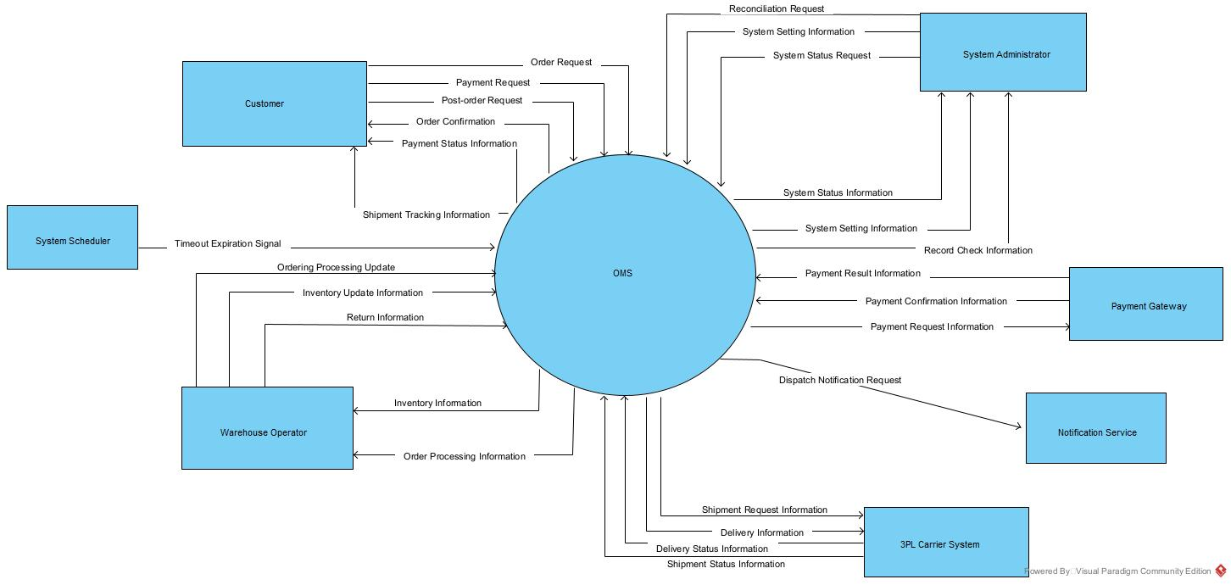

II.4 Nonfunctional requirements

# | Feature | System Function | Description
1 | Order Management | Order Expiration | The system automatically detects unpaid orders after the payment time limit and changes the order status to Cancelled.
2 | Inventory Management | Inventory Reservation | The system checks available inventory and reserves the required quantity when an order is placed.
3 | Inventory Management | Inventory Rollback | The system releases reserved inventory when an order is cancelled or expires before payment.
4 | Payment Management | Payment Processing | The system processes payment information, updates payment status, and stores payment history.
5 | Inventory Management | Inventory Allocation Control | The system controls concurrent inventory allocation to prevent two orders from reserving the same stock.
6 | Shipping Management | Shipment Status Synchronization | The system receives tracking and delivery information from the 3PL Carrier and updates the shipment status.
7 | Warehouse Management | Warehouse Routing | The system selects a suitable warehouse for order fulfillment based on routing rules and inventory availability.
8 | Reconciliation Management | Reconciliation Record Generation | The system creates reconciliation records from order, payment, inventory, and shipment data for system monitoring.

II.5 Functional requirements

II.5.1 Actors
# | Actor | Description
1 | Warehouse Operator | Internal warehouse personnel who receives order processing information, updates inventory information, and provides return information to the OMS.
2 | System Administrator | Internal system administrator who requests system status and system setting information, initiates reconciliation requests, and receives system status, system setting, and record check information from the OMS.
3 | Payment Gateway | External payment processing system that receives payment requests from the OMS and returns payment confirmation and payment result information.
4 | 3PL Carrier System | External payment processing system that receives payment requests from the OMS and returns payment confirmation and payment result information.
5 | Customer | External customer who submits order requests, payment requests, and post-order requests to the OMS, and receives order confirmations, payment status information, and shipment tracking information.
6 | Notification Service | External notification service that receives notification dispatch requests from the OMS and delivers order-related notifications to customers or other relevant recipients.
7 | System Scheduler | Automated scheduling component that sends timeout expiration signals to the OMS to trigger time-based order processing and maintenance activities.

II.5.2 Use Cases
ID | Use Case | Actor
UC-01 | Process Sales Order | Customer, Notification Service
UC-02 | Cancel Order | Customer, Notification Service
UC-03 | View Order Status | Customer
UC-04 | Process Payment Payment | Customer, Payment Gateway, Notification Service
UC-05 | Submit Return Request | Customer, Notification Service
UC-06 | View Fulfillment Orders | Warehouse Operator
UC-07 | Fulfill Order | Warehouse Operator, Notification Service
UC-08 | Dispatch Order Shipment | Warehouse Operator, 3PL Carrier System, Notification Service
UC-09 | Process Returned Order | Warehouse Operator, Notification Service
UC-10 | Manage Products | System Administrator
UC-11 | Manage SKUs | System Administrator
UC-12 | Manage Warehouses | System Administrator
UC-13 | Configure Order Routing | System Administrator
UC-14 | Monitor System Operations | System Administrator
UC-15 | Perform Order & Payment Reconciliation | System Administrator
UC-16 | Accept Shipment | 3PL Carrier System
UC-17 | Update Shipment Status | 3PL Carrier System
UC-18 | Confirm Delivery & Collect COD Payment | 3PL Carrier System, Notification Service
UC-19 | Authenticate User | Warehouse Operator, System Administrator
UC-20 | Process Order Timeout | System Scheduler, Notification Service

II.5.2 .1 Diagram(s)
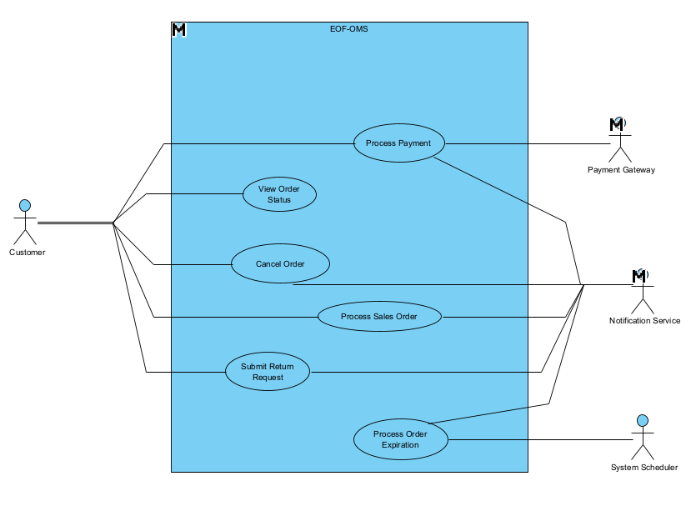
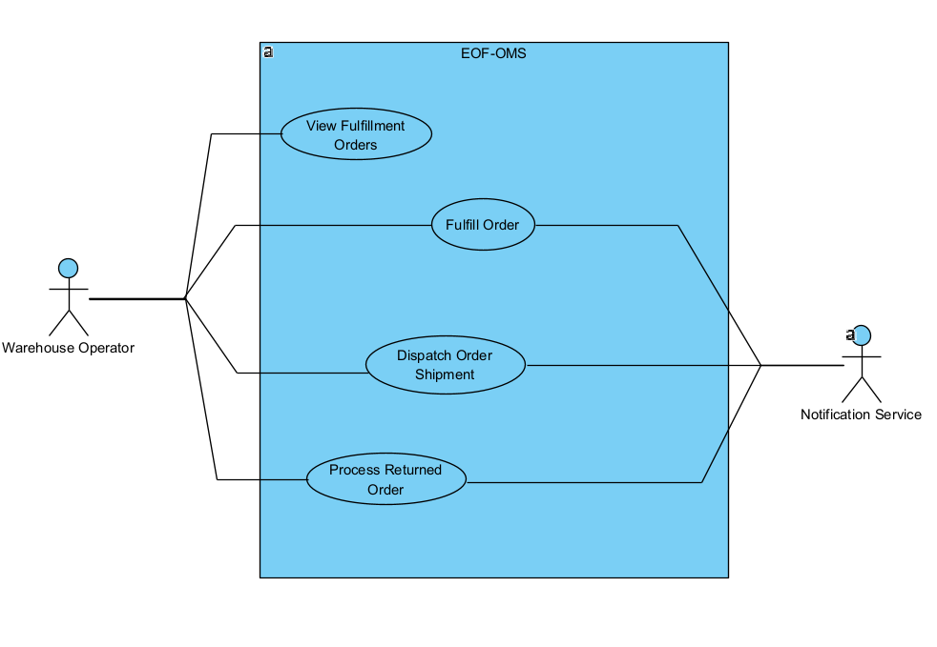
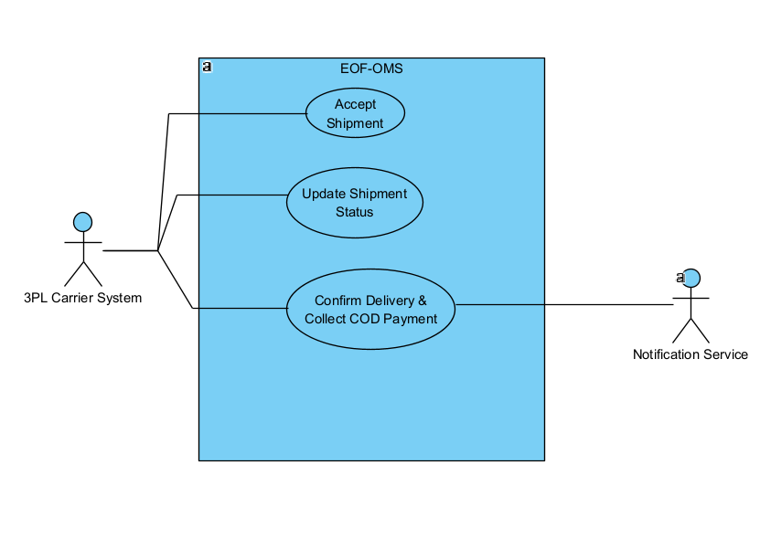
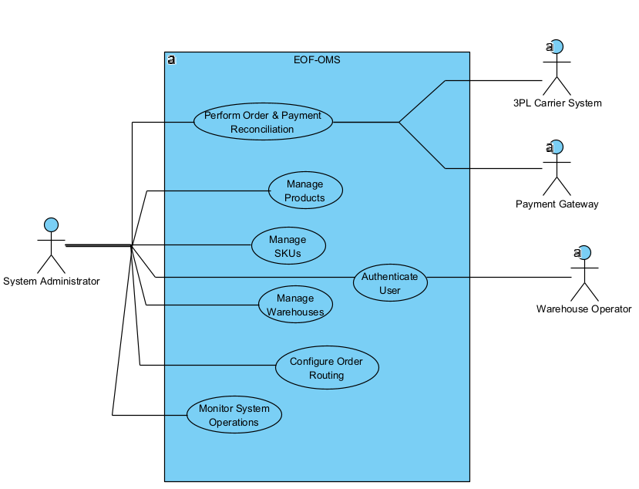

II.5.2.2 Use case descriptions
This part describes the use cases, you can follow the table form as below]
ID | Use Case | Actors | Use Case Description
UC-01 | Process Sales Order | Customer, Notification Service | Receives customer sales order requests, validates data, determines routing, reserves inventory, and triggers order confirmations.
UC-02 | Cancel Order | Customer, Notification Service | Handles order cancellation requests prior to dispatch, releases reserved inventory, and triggers cancellation notifications.
UC-03 | View Order Status | Customer | Provides real-time order lifecycle status, payment verification details, and 3PL shipping tracking information.
UC-04 | Process Payment | Customer, Payment Gateway, Notification Service | Processes prepaid transactions via gateway callbacks, updates payment states, and releases eligible orders to fulfillment.
UC-05 | Submit Return Request | Customer, Notification Service | Accepts customer return requests for delivered items, verifies policy eligibility, and generates return authorizations.
UC-06 | View Fulfillment Orders | Warehouse Operator | Displays allocated orders that meet fulfillment eligibility (Verified prepaid or confirmed COD).
UC-07 | Fulfill Order | Warehouse Operator, Notification Service | Picks and packs items for eligible orders and prepares parcels.
UC-08 | Dispatch Shipment | Warehouse Operator, 3PL Carrier System, Notification Service | Dispatches packed parcels and hands over to carrier with tracking/waybill generation.
UC-09 | Process Returned Order | Warehouse Operator, Notification Service | Inspects physically returned goods, records item conditions, updates restock inventory, and triggers return processing updates.
UC-10 | Manage Products | System Administrator | Maintains master product information, attributes, and catalog visibility in the platform.
UC-11 | Manage SKUs | System Administrator | Manages SKU-level identifiers and product variants linked directly to inventory tracking.
UC-12 | Manage Warehouses | System Administrator | Manages warehouse details, capacities, and active statuses.
UC-13 | Configure Order Routing | System Administrator | Configures rules, prioritization logic, and split-shipment policies for optimal warehouse allocation.
UC-14 | Monitor System Operations | System Administrator | Monitors real-time order processing queues, stock reservation status, system latencies, and service health.
UC-15 | Perform Order & Payment Reconciliation | System Administrator | Reviews and resolves payment gateway, inventory balance, and 3PL COD cash collection discrepancy logs.
UC-16 | Accept Shipment | 3PL Carrier | Carrier accepts dispatch request and returns tracking number.
UC-17 | Update Shipment Status | 3PL Carrier | Carrier sends transit updates and milestone events to OMS.
UC-18 | Confirm Delivery & Collect COD Payment | 3PL Carrier System, Notification Service | Carrier system confirms successful parcel delivery, reports COD cash collection, and updates order completion.
UC-19 | Authenticate User | Warehouse Operator, System Administrator | Authenticates internal users into the OMS console.
UC-20 | Process Order Expiration | System Scheduler, Notification Service | Automated Order Expiration & Inventory Rollback

1 <<UseCaseCode_UC Name>>
Functional Description Template
UC ID and Name: | UC-01 – Process Sales Order
Created By: | Phạm Văn Tùng | Date Created: | 23/09/2026
Primary Actor: | Customer | Secondary Actors: | Notification Service
Trigger: | Web Storefront submits a standardized sales order request to the OMS.
Description: | Receives an external order request containing order line items, customer details, delivery address, and payment method; determines fulfillment warehouses; concurrently reserves inventory; and establishes payment fulfillment eligibility.
Preconditions: | PRE-1: Web Storefront is authenticated via secure API credentials.  PRE-2: Order request contains valid SKU identifiers, positive quantities, and complete delivery address.  PRE-3: A valid payment method is specified (Prepaid or COD).
Postconditions: | POST-1: Sales order is created in OMS with a unique Order ID in Created state.  POST-2: Required inventory is reserved across allocated warehouses.  POST-3: If Prepaid: Order transitions to Inventory-Reserved & Awaiting-Payment; 15-minute expiration countdown timer starts.  POST-4: If COD: Order transitions to Inventory-Reserved & Ready-for-Fulfillment (eligible for picking).  POST-5: Order Status Information is returned to the Web Storefront.  POST-6: Order confirmation notification request is dispatched to the Notification Service.
Normal Flow: | 1.0 Web Storefront transmits Order Information, Customer Information, and Delivery Information to OMS.  1.1 System validates order payload structure, SKU existence, and delivery destination.  1.2 System determines optimal fulfillment warehouse(s) based on configured routing rules.  1.3 System concurrently checks and reserves required inventory for the allocated SKUs.  1.4 System creates the order in Created state.  1.5 System evaluates the selected payment method:  - If Prepaid: sets payment status to Pending, initiates 15-minute expiration timer, and sets order state to Awaiting-Payment.  - If COD: sets payment status to Pending_COD, flags order as Fulfillment-Eligible, and bypasses advance payment requirement.  1.6 System confirms inventory reservation and sets order state to Inventory-Reserved.  1.7 System returns Order Status Information (Order ID, reservation status, payment requirements) to Web Storefront.  1.8 System dispatches an order confirmation notification request to Notification Service.  1.9 Notification Service receives the notification request for delivery of order confirmation to the customer.
Alternative Flows: | 1.2a Multi-warehouse allocation:  1.2a.1 System detects a single warehouse lacks sufficient stock for all line items.  1.2a.2 System splits line items across multiple eligible warehouses based on routing priority.  1.2a.3 System creates separate fulfillment allocations linked to parent Order ID.  1.2a.4 Flow resumes at step 1.3.  1.5a High-value COD order threshold review:  1.5a.1 System detects COD total exceeds policy threshold limit.  1.5a.2 System flags order state as Pending-Review and notifies sales channel for customer confirmation.  1.5a.3 System resumes step 1.6 upon receiving confirmation.  1.7a Synchronous instant checkout response:  1.7a.1 Sales channel requests immediate synchronous confirmation for customer checkout screen.  1.7a.2 System returns reservation token and estimated delivery dates within synchronous response.
Exceptions: | 1.1.E1: Insufficient inventory.  1.1.E1.1 System rejects order placement, returns Out-of-Stock error to Web Storefront, and logs attempt.  1.2.E1: Invalid routing configuration. System logs routing failure exception and rejects order request.  1.5.E1: COD payment method not serviceable for destination. System prompts storefront to select another payment method.
Priority: | High
Frequency of Use: | High; potentially hundreds or thousands of requests per hour depending on traffic.
Business Rules: | BR3, BR4, BR6,BR7, BR8BR9
Other Information: | This use case is a core event-driven transaction and must maintain transactional consistency.
Assumptions: | Prepaid orders require external gateway completion before warehouse handling; COD orders are ready for warehouse fulfillment immediately after reservation.

UC ID and Name: | UC-02 – Cancel Order
Created By: | Phạm Văn Tùng | Date Created: | 23/09/2026
Primary Actor: | Customer | Secondary Actors: | Notification Service
Trigger: | Web Storefront transmits an order cancellation request to OMS.
Description: | Processes cancellation requests for eligible orders, releases reserved inventory back to available stock, and initiates refund procedures for prepaid orders.
Preconditions: | PRE-1: Order exists in the OMS database.  PRE-2: Order is in a cancellable state (has not reached non-cancellable fulfillment or dispatch).
Postconditions: | POST-1: Order state transitions to Cancelled.  POST-2: Reserved inventory is released back to available stock.  POST-3: Cancellation confirmation is returned to Web Storefront.
Normal Flow: | 2.0 Web Storefront transmits cancellation request containing Order ID and cancellation reason.  2.1 System verifies current order status and checks cancellation eligibility.  2.2 System transitions order state to Cancelled.  2.3 System releases all reserved inventory items for the order back to available stock.  2.4 System evaluates payment method:  - If verified Prepaid order: creates refund transaction record for Payment Gateway processing.  - If unverified Prepaid order: cancels 15-minute expiration timer without financial refund.  - If COD order: bypasses financial refund creation.  2.5 System returns cancellation confirmation and inventory release status to Web Storefront.  2.6 System dispatches a cancellation notification request to Notification Service.
Alternative Flows: | 2.1a Order is currently in warehouse picking/packing stage:  2.1a.1 System detects warehouse fulfillment task is in progress (Picking/Packed).  2.1a.2 System issues an immediate "Hold/Cancel Picking" alert to the warehouse console.  2.1a.3 System waits for Warehouse Operator acknowledgment before finalizing inventory release.  2.1a.4 Flow resumes at step 2.2.  2.3a Inventory release failure requires reconciliation:  2.3a.1 Distributed inventory service timeout occurs during release.  2.3a.2 System logs compensation failure into reconciliation queue for automated retry.  2.3a.3 Flow resumes at step 2.4.
Exceptions: | 2.1.E1: Order already shipped or delivered. System rejects cancellation request and informs Web Storefront that order must follow Return process.  2.2.E1: Order does not exist. System returns invalid order identifier error.
Priority: | High
Frequency of Use: | Medium
Business Rules: | BR2: An order can only be cancelled when its current state allows cancellation.  BR5: Reserved inventory must be released when the order is cancelled or expires before fulfillment.  BR13: The system generates appropriate status integration events to the Web Storefront on defined order, payment, shipment, and delivery events.
Other Information: | Cancellation and inventory release should be handled consistently even when asynchronous events are involved.
Assumptions: | Refund rules and execution are handled asynchronously by the payment gateway subsystem where applicable.

UC ID and Name: | UC-03 – View Order Status
Created By: | Phạm Văn Tùng | Date Created: | 23/09/2026
Primary Actor: | Customer | Secondary Actors:
Trigger: | Web Storefront queries order status or OMS publishes real-time lifecycle update.
Description: | Supplies current order lifecycle status, payment settlement status, fulfillment milestones, and carrier tracking details to the sales channel.
Preconditions: | PRE-1: Order exists in the OMS database.
Postconditions: | POST-1: Up-to-date order and shipment status payload is delivered to Web Storefront.
Normal Flow: | 3.0 Web Storefront requests status update for a specific Order ID.  3.1 System queries order lifecycle state, payment status, and fulfillment task progress.  3.2 System retrieves 3PL tracking number and transit milestone logs if order has been dispatched.  3.3 System compiles status payload and returns Order Status Information to Web Storefront.
Alternative Flows: | 3.0a Batch order status inquiry:  3.0a.1 Web Storefront sends a list of multiple Order IDs.  3.0a.2 System queries and returns an aggregated status array for all requested orders.  3.2a Order is in Return / Refund process:  3.2a.1 System detects return request is active for the order.  3.2a.2 System attaches return tracking, inspection outcome, and refund status to the payload.  3.2b 3PL Tracking service temporarily unreachable:  3.2b.1 Real-time carrier API is offline.  3.2b.2 System returns latest locally-cached tracking checkpoint with an "As of [timestamp]" indicator.
Exceptions: | 3.1.E1: Order ID not found. System returns HTTP 404 with error description.
Priority: | High
Frequency of Use: | High
Business Rules: | BR19: Sales channels can only access order information belonging to their authenticated channel identity.
Other Information: | Status information should reflect current order state in real time.
Assumptions: | Web Storefront queries status on behalf of the customer or receives webhook events.

UC ID and Name: | UC-04 – Process Payment
Created By: | Phạm Văn Tùng | Date Created: | 23/09/2026
Primary Actor: | Customer | Secondary Actors: | Payment Gateway, Notification Service
Trigger: | Payment Gateway transmits an asynchronous payment callback/webhook to OMS.
Description: | Validates payment verification results for prepaid orders, updates payment status, and advances eligible orders to warehouse fulfillment. (Note: COD orders do not use this gateway flow).
Preconditions: | PRE-1: Matching prepaid order exists in Awaiting-Payment state.  PRE-2: Order is within valid 15-minute payment window.
Postconditions: | POST-1: Payment transaction status is updated to Verified.  POST-2: Order state transitions to Payment-Verified and becomes eligible for fulfillment.  POST-3: Payment Status Information is published to Web Storefront.
Normal Flow: | 4.0 Payment Gateway transmits Payment Result Information and Payment Confirmation Information to OMS.  4.1 System verifies the digital signature of the callback payload.  4.2 System checks callback idempotency to prevent duplicate transaction recording.  4.3 System matches transaction to internal Order ID.  4.4 System updates payment record to Verified.  4.5 System transitions order to Payment-Verified, releasing order to warehouse fulfillment queue.  4.6 System cancels the 15-minute expiration timer.  4.7 System transmits Payment Status Information to Web Storefront.  4.8 System dispatches payment confirmation notification to Notification Service.
Alternative Flows: | 4.4a Payment Failed / Rejected by Issuer:  4.4a.1 Payment gateway reports transaction failure (insufficient funds, card declined).  4.4a.2 System records Payment-Failed status.  4.4a.3 System keeps order in Awaiting-Payment state for remainder of 15-minute window to allow customer retry.  4.4a.4 System notifies Web Storefront of failure with retry token.  4.4a.5 System dispatches payment failure notification to Notification Service.  4.4b Payment Pending / Processing:  4.4b.1 Gateway reports payment is processing (e.g., bank transfer pending clearing).  4.4b.2 System sets status to Payment-Processing and awaits further webhook updates.  4.6a Late payment callback received after order expiration:  4.6a.1 Payment arrives after 15-minute timer expired and order was marked Cancelled.  4.6a.2 System verifies signature, accepts payment, but marks transaction as Unmatched-Expired.  4.6a.3 System creates an automatic refund task and logs reconciliation discrepancy for administrative review.
Exceptions: | 4.1.E1: Signature validation fails. System flags transaction for security audit, discards payload, and logs error.  4.2.E1: Duplicate callback received (already processed). System acknowledges HTTP 200 to gateway without re-processing state.
Priority: | High
Frequency of Use: | High during normal shopping periods; potentially concurrent.
Business Rules: | BR7: An order can proceed to fulfillment only when its payment condition is satisfied.  BR8: Unpaid prepaid orders must expire after 15 minutes.  BR20: Each payment transaction must have a unique transaction identifier.  BR22: Payment results from gateway must be validated before updating order status.  BR23: Duplicate callbacks must not trigger duplicate processing (Idempotency).  BR37: For prepaid orders, if payment callback and order expiration occur concurrently, system must revalidate state before finalizing cancellation.
Other Information: | Payment processing is asynchronous and must support reconciliation for uncertain transactions.
Assumptions: | The payment gateway provides a secure API/callback mechanism.

UC ID and Name: | UC-05 – Submit Return Request
Created By: | Phạm Văn Tùng | Date Created: | 23/09/2026
Primary Actor: | Customer | Secondary Actors: | Notification Service
Trigger: | Web Storefront transmits a customer return request to OMS.
Description: | Receives and validates customer return requests forwarded by sales channels, checks return eligibility policies, and generates incoming return authorization for warehouse processing.
Preconditions: | PRE-1: Order exists in OMS in Delivered state.  PRE-2: Order is within valid return window (e.g., 7 days from delivery).
Postconditions: | POST-1: Return Request record is created in Return-Authorized state.  POST-2: Return task is assigned to receiving warehouse.  POST-3: Return confirmation is sent back to Web Storefront.
Normal Flow: | 5.0 Web Storefront transmits return request with Order ID, SKU line items, return reason, and condition description.  5.1 System checks order delivery date and verifies return eligibility.  5.2 System verifies that an active return request does not already exist for the specified items.  5.3 System creates a Return Request record and designates receiving warehouse.  5.4 System transmits Return Authorization and return shipping instructions to Web Storefront.
Alternative Flows: | 5.1a Partial item return:  5.1a.1 Customer requests return for only 1 out of multiple delivered items.  5.1a.2 System generates return authorization for specific line item while keeping other items intact.  5.1a.3 Flow resumes at step 5.3.  5.1b Return window expired:  5.1b.1 Order delivery date exceeds standard return policy window.  5.1b.2 System automatically rejects request and returns policy expiration notice to Web Storefront.
Exceptions: | 5.1.E1: Order ID not found or order has not been marked Delivered. System rejects request.  5.2.E1: Duplicate active return request exists. System rejects duplicate request.
Priority: | High
Frequency of Use: | Medium to High.
Business Rules: | BR14: A return request can only be submitted for orders or items that satisfy configured return conditions.  BR17: Each SKU must belong to a valid product.
Other Information: | Return status should be traceable by the sales channel.
Assumptions: | Customer return inquiries are submitted via the storefront interface.

UC ID and Name: | UC-06 – View Fulfillment Orders
Created By: | Phạm Văn Tùng | Date Created: | 23/09/2026
Primary Actor: | Warehouse Operator | Secondary Actors:
Trigger: | Warehouse Operator opens the fulfillment order list.
Description: | Displays orders allocated to the operator's warehouse that have satisfied fulfillment eligibility (Prepaid orders with verified payment OR COD orders with confirmed inventory reservation).
Preconditions: | PRE-1: Warehouse Operator is authenticated and authorized.
Postconditions: | POST-1: Fulfillment queue is displayed, filtering out unverified prepaid orders.
Normal Flow: | 6.0 Operator opens fulfillment orders screen.  6.1 System identifies operator's authorized warehouse(s).  6.2 System queries orders allocated to this warehouse that meet fulfillment eligibility:  - Prepaid orders with Payment Status = Verified.  - COD orders with Payment Status = Pending_COD and inventory reserved.  6.3 System displays order list including Order ID, items, SKU quantities, payment type (Prepaid vs COD flag), priority, and creation timestamp.  6.4 Operator reviews queue to begin picking process.
Alternative Flows: | 6.3a Filter and sort fulfillment queue:  6.3a.1 Operator filters orders by payment method (e.g., View only COD or only Prepaid) or shipping priority (Express vs Standard).  6.3a.2 System refreshes queue matching selected criteria.  6.3b Bulk task assignment:  6.3b.1 Operator selects multiple orders to assign to a specific warehouse picker.  6.3b.2 System generates a consolidated picking batch and updates status to In-Picking.
Exceptions: | 6.1.E1: Operator is unauthorized. System denies access.  6.2.E1: No eligible fulfillment orders found. System displays empty state.
Priority: | High
Frequency of Use: | High during warehouse operating periods.
Business Rules: | BR7: An order can proceed to fulfillment only when its payment condition is satisfied.  BR9: Only orders with valid inventory allocation and verified payment (or confirmed COD) can proceed to fulfillment.  BR23: Duplicate payment callbacks for the same transaction must not cause duplicate processing or invalid state transitions.  BR25: Only active and eligible warehouses can receive fulfillment tasks.  BR32: A Warehouse Operator can only view fulfillment tasks belonging to authorized warehouses.
Other Information: | Fulfillment information should reflect current order state.
Assumptions: | Unpaid prepaid orders are strictly excluded from the queue until payment verification is received.

UC ID and Name: | UC-07 – Fulfill Order
Created By: | Phạm Văn Tùng | Date Created: | 23/09/2026
Primary Actor: | Warehouse Operator | Secondary Actors: | Notification Service
Trigger: | Warehouse Operator starts processing an assigned fulfillment order.
Description: | Allows the warehouse operator to pick and pack reserved order items and prepare them for carrier dispatch, applicable to both verified prepaid orders and confirmed COD orders.
Preconditions: | PRE-1: Order has a valid inventory reservation.  PRE-2: Fulfillment task is allocated to the warehouse.  PRE-3: Order satisfies payment fulfillment eligibility (Prepaid orders must be Payment-Verified; COD orders must be Confirmed without advance payment).
Postconditions: | POST-1: Items are picked, verified against SKUs, and packed.  POST-2: Package details (weight, dimensions, COD collection label) are recorded.  POST-3: Fulfillment status is updated to Packed / Ready for Dispatch.
Normal Flow: | 7.0 Operator selects an eligible order from fulfillment queue.  7.1 System displays picking list with items, SKUs, and bin locations.  7.2 Operator picks required items from storage bins.  7.3 Operator confirms picked quantities.  7.4 Operator packs items into parcel(s) and records parcel specifications (weight, dimensions).  7.5 If order is COD, System generates packing slip clearly showing "COD Amount to Collect from Recipient".  7.6 Operator confirms packing completion.  7.7 System transitions order status to Packed / Ready for Handover.
Alternative Flows: | 7.2a Wave / Batch Picking:  7.2a.1 Operator picks SKUs for multiple orders simultaneously in a single warehouse route.  7.2a.2 Operator brings items to sorting station and scans each item to assign to individual orders.  7.2a.3 Flow resumes at step 7.4.  7.4a Multi-package packing:  7.4a.1 Order size exceeds single parcel capacity.  7.4a.2 Operator records dimensions and weights for Box 1, Box 2, etc.  7.4a.3 System creates sub-package IDs under parent order and resumes step 7.5.  7.5a Reprint packing slip / shipping label:  7.5a.1 Printer jam or barcode defect occurs.  7.5a.2 Operator requests label re-print; System re-generates identical barcode and documents print audit log.
Exceptions: | 7.2.E1: Item damaged or stock discrepancy discovered during picking. Operator flags fulfillment exception; system triggers reconciliation and prompts partial fulfillment or warehouse re-routing.  7.6.E1: Order was cancelled while picking was in progress. System blocks packing and instructs operator to return items to storage bins.
Priority: | High
Frequency of Use: | High.
Business Rules: | BR9: Only orders with valid allocation and payment eligibility can proceed to fulfillment.  BR27: A warehouse must not fulfill more items than allocated for the corresponding order item.
Other Information: | Fulfillment should be traceable by warehouse and order item.
Assumptions: | Warehouse fulfills physical goods regardless of whether payment was collected in advance (Prepaid) or will be collected upon delivery (COD).

UC ID and Name: | UC-08 – Dispatch Order Shipment
Created By: | Phạm Văn Tùng | Date Created: | 23/09/2026
Primary Actor: | Warehouse Operator | Secondary Actors: | 3PL Carrier, Notification Service
Trigger: | Warehouse Operator completes packing and requests shipment dispatch.
Description: | Sends a completed fulfillment shipment to the selected 3PL carrier.
Preconditions: | PRE-1: Order has been fulfilled and packed.  PRE-2: A valid 3PL carrier is available.  PRE-3: Shipment information is complete.
Postconditions: | POST-1: Dispatch request is submitted to the carrier.  POST-2: Tracking/waybill number is recorded.  POST-3: Order transitions to Shipped status.  POST-4: Order Status Information is published to Web Storefront.
Normal Flow: | 8.0 Operator selects a completed fulfillment package.  8.1 System validates shipment information and generates carrier manifest (including COD amount if COD order).  8.2 System transmits Shipment Request Information to the 3PL Carrier System.  8.3 3PL Carrier System accepts shipment request and returns tracking/waybill number.  8.4 System records tracking number.  8.5 Operator hands parcel to carrier personnel.  8.6 System updates order status to Shipped.  8.7 System transmits Order Status Information (including tracking number) to Web Storefront.
Alternative Flows: | 8.1a Bulk handover manifest dispatch:  8.1a.1 Carrier truck arrives for scheduled daily pickup.  8.1a.2 Operator scans all packed parcels to generate a Master Handover Manifest.  8.1a.3 3PL driver signs electronically; System dispatches all associated orders to Shipped in bulk.  8.3a Multi-piece shipment tracking:  8.3a.1 Order contains multiple packages (from UC-W02 Alt 7.4a).  8.3a.2 3PL returns individual sub-tracking numbers linked to a master airway bill.  8.3a.3 System associates all tracking numbers with the order and resumes step 8.5.
Exceptions: | 8.2.E1: 3PL rejects dispatch request (e.g. invalid postal code). System records failure and keeps order in Packed state for operator review.  8.2.E2: Carrier API timeout/failure. System queues request in retry scheduler and marks status as Handover-Pending.
Priority: | High
Frequency of Use: | High.
Business Rules: | BR10: An order can only be marked as Shipped after successful dispatch and carrier handover.  BR11: A dispatched shipment must have a valid carrier tracking identifier.  BR30: Carrier events must be validated before changing shipment status.  BR31: Duplicate carrier events must not create duplicate shipment records.
Other Information: | 3PL integration should be asynchronous where appropriate.
Assumptions: | The 3PL provides a unique tracking/waybill number.

UC ID and Name: | UC-09 – Process Returned Order
Created By: | Phạm Văn Tùng | Date Created: | 23/09/2026
Primary Actor: | Warehouse Operator | Secondary Actors: | Notification Service
Trigger: | Warehouse Operator receives a returned item.
Description: | Allows warehouse staff to inspect and process returned products.
Preconditions: | PRE-1: A valid return request exists in the system.  PRE-2: Returned goods are physically received at the warehouse.
Postconditions: | POST-1: Inspection result is recorded.  POST-2: Return status is updated to Completed.  POST-3: Inventory is updated if items are eligible for restocking.  POST-4: Return Status Information is sent to Web Storefront.
Normal Flow: | 9.0 Operator opens return request in OMS console.  9.1 Operator inspects returned physical items.  9.2 Operator records inspection result (intact, damaged, wrong item).  9.3 System updates return status.  9.4 If item is restockable, System increments available warehouse inventory.  9.5 System transmits Return Status Information to Web Storefront.
Alternative Flows: | 9.2a Damaged / Unsealed item (Non-restockable):  9.2a.1 Operator identifies item is broken, used, or unsealed.  9.2a.2 Operator records item as "Damaged/Discard".  9.2a.3 System routes item to salvage/disposal log without increasing available inventory.  9.2a.4 Flow resumes at step 9.5 with damage assessment notes.  9.2b Partial return inspection:  9.2b.1 Customer returned only 1 out of 2 items in order.  9.2b.2 Operator confirms receipt of item 1 and marks item 2 as missing.  9.2b.3 System processes restock and partial refund calculations accordingly.
Exceptions: | 9.0.E1: Return request not found. System flags parcel as unidentified return and quarantines item.  9.1.E1: Customer returned an incorrect item (different SKU). System records return discrepancy and notifies Web Storefront.
Priority: | Medium
Frequency of Use: | Low to Medium.
Business Rules: | BR28: Returned items must be inspected before restocking.  BR29: Only returned items that pass inspection can be added back to available inventory.
Other Information: | Return discrepancies should be available for reconciliation.
Assumptions: | Return inspection rules are defined by the business.

UC ID and Name: | UC-10 – Manage Products
Created By: | Phạm Văn Tùng | Date Created: | 23/09/2026
Primary Actor: | System Administrator | Secondary Actors:
Trigger: | Administrator creates, updates, views, or deactivates a product.
Description: | Allows administrators to maintain product information in the platform.
Preconditions: | PRE-1: Administrator is authenticated and authorized.
Postconditions: | POST-1: Product information is created, updated, or deactivated successfully.
Normal Flow: | 10.0 Administrator opens product management console.  10.1 System displays product master list.  10.2 Administrator enters or modifies product information.  10.3 System validates product data structure and uniqueness.  10.4 System commits changes and updates product audit trail.
Alternative Flows: | 10.2a Deactivate product:  10.2a.1 Administrator deactivates a product.  10.2a.2 System flags product as inactive, preventing new orders while preserving historical order references.
Exceptions: | 10.3.E1: Product identifier already exists. System rejects change with error notice.
Priority: | High
Frequency of Use: | Low to Medium.
Business Rules: | BR15: Only authorized system administrators can manage products.  BR16: Only active products can be displayed and included in new orders.  BR33: Historical order data must not be invalidated by product deactivation.
Other Information: | Product changes should be auditable.
Assumptions: | Only authorized administrators can manage products.

UC ID and Name: | UC-11 – Manage SKUs
Created By: | Phạm Văn Tùng | Date Created: | 23/09/2026
Primary Actor: | System Administrator | Secondary Actors:
Trigger: | Administrator creates or updates an SKU.
Description: | Allows administrators to manage SKU-level identifiers and product variants.
Preconditions: | PRE-1: Administrator is authenticated and authorized.  PRE-2: Parent product exists in active catalog.
Postconditions: | POST-1: SKU variant is saved and available for inventory tracking.
Normal Flow: | 11.0 Administrator opens SKU management console.  11.1 System displays existing SKUs and variant attributes.  11.2 Administrator creates or modifies an SKU.  11.3 System validates SKU uniqueness and parent product association.  11.4 System commits SKU record.
Alternative Flows: | 11.2a SKU deactivation:  11.2a.1 Administrator disables an SKU.  11.2a.2 System disables new allocations for SKU without deleting historical orders.
Exceptions: | 11.3.E1: SKU code duplicated. System rejects creation.  11.3.E2: Parent product does not exist. System rejects SKU creation.
Priority: | High, Must Have
Frequency of Use: | Medium.
Business Rules: | BR15: Only authorized administrators can manage SKUs.  BR17: Each SKU must belong to a valid product, and SKU identifiers must be unique.  BR33: Deactivating SKUs must not invalidate historical records.
Other Information: | SKU data is directly related to inventory allocation.
Assumptions: | Inventory is tracked at SKU level.

UC ID and Name: | UC-12 – Manage Warehouses
Created By: | Phạm Văn Tùng | Date Created: | 23/09/2026
Primary Actor: | System Administrator | Secondary Actors:
Trigger: | Administrator creates, updates, activates, or deactivates a warehouse.
Description: | Allows administrators to maintain warehouse information used for inventory and fulfillment.
Preconditions: | PRE-1: Administrator is authenticated and authorized.
Postconditions: | POST-1: Warehouse information is updated.
Normal Flow: | 12.0 Administrator opens warehouse configuration screen.  12.1 Administrator enters warehouse facility parameters (name, address, operational status).  12.2 System validates unique warehouse code.  12.3 System commits warehouse configuration.
Alternative Flows: | 12.1a Deactivate warehouse:  12.1a.1 Administrator marks warehouse as inactive.  12.1a.2 System blocks new allocations to this warehouse; ongoing fulfillment tasks must be completed or re-routed.
Exceptions: | 12.2.E1: Warehouse code conflict. System rejects submission.  12.2.E2: Active fulfillment operations exist in warehouse during attempted deletion. System prevents deletion.
Priority: | High
Frequency of Use: | Low.
Business Rules: | BR15: Only authorized administrators can manage warehouses.  BR25: Only active/eligible warehouses receive new allocation/fulfillment tasks.  BR33: Deactivating warehouses must not invalidate historical fulfillment records.
Other Information: | Existing historical orders must remain associated with their original warehouse.
Assumptions: | Warehouse inventory is maintained separately by SKU.

UC ID and Name: | UC-13 – Configure Order Routing
Created By: | Phạm Văn Tùng | Date Created: | 23/09/2026
Primary Actor: | System Administrator | Secondary Actors:
Trigger: | Administrator creates or changes warehouse routing rules.
Description: | Allows administrators to configure the rules used to select fulfillment warehouses for orders.
Preconditions: | PRE-1: Administrator is authenticated and authorized.  PRE-2: Warehouses required by the rule exist and are active.
Postconditions: | POST-1: Routing configuration is saved and available for future allocation decisions.
Normal Flow: | 13.0 Administrator opens routing configuration screen.  13.1 Administrator defines geographic rules, shipping zones, or priority rankings.  13.2 System validates that no cyclic or conflicting rules exist.  13.3 System activates new routing rule configuration.
Alternative Flows: | 13.1a Temporary rule disablement:  13.1a.1 Administrator suspends a routing rule during warehouse maintenance.  13.1a.2 System shifts traffic to fallback routing rule.
Exceptions: | 13.2.E1: Conflicting routing rules detected. System prevents activation until conflicts are resolved.  13.2.E2: Rule references an inactive warehouse. System rejects rule configuration.
Priority: | High, Must Have
Frequency of Use: | Low.
Business Rules: | BR6: Allocation follows configured warehouse routing rules and eligible warehouse availability.  BR15: Only authorized administrators can configure routing rules.  BR26: Warehouse routing rules must reference valid warehouses and contain no conflicts.
Other Information: | Changes should be auditable because they affect inventory allocation.
Assumptions: | Routing rules are evaluated during order placement.

UC ID and Name: | UC-14 – Monitor System Operations
Created By: | Phạm Văn Tùng | Date Created: | 23/09/2026
Primary Actor: | System Administrator | Secondary Actors:
Trigger: | Administrator opens the system monitoring interface.
Description: | Allows administrators to monitor system health, order processing, integration status, and operational events.
Preconditions: | PRE-1: Administrator is authenticated and authorized.
Postconditions: | POST-1: Real-time operational metrics and health dashboard are displayed.
Normal Flow: | 14.0 Administrator accesses monitoring dashboard.  14.1 System aggregates metrics across order ingestion, inventory lock latency, and carrier integration endpoints.  14.2 System displays operational dashboard.
Alternative Flows: | 14.1a Filter by service or time range:  14.1a.1 Administrator filters monitoring data by specific service (Payment, Fulfillment, Carrier).  14.1a.2 System recalculates performance indicators for selected window.
Exceptions: | 14.1.E1: Monitoring metrics service timeout. System alerts administrator of partial metrics display.
Priority: | Medium
Frequency of Use: | Medium to High during operational periods.
Business Rules: | BR15: Monitoring data must be accessible only to authorized administrators.
Other Information: | Monitoring should support detection of failed asynchronous processing and integration problems.
Assumptions: | System logs and monitoring metrics are collected continuously.

UC ID and Name: | UC-15 – Perform Order & Payment Reconciliation
Created By: | Phạm Văn Tùng | Date Created: | 23/09/2026
Primary Actor: | System Administrator | Secondary Actors:
Trigger: | Administrator opens reconciliation records.
Description: | Reviews asynchronous transaction discrepancies, payment callback mismatches, COD settlement gaps, and inventory allocation exceptions.
Preconditions: | PRE-1: Administrator is authenticated and authorized.
Postconditions: | POST-1: Reconciliation logs and discrepancy items are displayed.
Normal Flow: | 15.0 Administrator opens reconciliation console.  15.1 System queries unresolved reconciliation logs (payment gateway mismatches, carrier COD differences).  15.2 System displays discrepancy records with full event history.  15.3 Administrator marks records as resolved or initiates manual audit correction.
Alternative Flows: | 15.2a Export reconciliation report:  15.2a.1 Administrator requests data export.  15.2a.2 System generates CSV/Excel report for financial accounting and audit.
Exceptions: | 15.1.E1: Reconciliation database unavailable. System returns error message.
Priority: | Medium, Should Have
Frequency of Use: | Low to Medium.
Business Rules: | BR15: Authorized system admins manage products, SKUs, warehouses, routing rules.  BR24: Unmatched, failed, or inconsistent transactions must be recorded for reconciliation.  BR35: Reconciliation records must preserve transaction and event traceability.
Other Information: | Reconciliation is particularly important for asynchronous payment and inventory events.
Assumptions: | Failed or uncertain transactions generate reconciliation records.

UC ID and Name: | UC-16 – Accept Shipment
Created By: | Phạm Văn Tùng | Date Created: | 23/09/2026
Primary Actor: | 3PL Carrier | Secondary Actors:
Trigger: | 3PL Carrier receives a shipment from the warehouse.
Description: | Represents the carrier accepting a parcel from the warehouse for delivery.
Preconditions: | PRE-1: Shipment has been prepared.  PRE-2: Shipment information is valid.  PRE-3: Carrier is assigned to the shipment.
Postconditions: | POST-1: Shipment is accepted by the carrier.  POST-2: Carrier tracking information is available.  POST-3: Order can transition to Shipped.
Normal Flow: | 216.0 Carrier receives dispatch request via API.  16.1 Carrier validates package weight, dimensions, and destination postal code.  16.2 Carrier registers consignment and returns tracking identifier to OMS.  16.3 System updates order record with carrier tracking number.
Alternative Flows: | 16.1a Remote location surcharge:  16.1a.1 Carrier calculates supplementary delivery fee.  16.1a.2 Carrier attaches fee code to consignment record and continues to step 16.2.
Exceptions: | 16.1.E1: Destination address unserviceable. Carrier rejects dispatch request.
Priority: | High, Must Have
Frequency of Use: | High.
Business Rules: | BR10: An order can only be marked as Shipped after successful dispatch and carrier handover.  BR11: A dispatched shipment must have a valid carrier tracking identifier.  BR30: Carrier events must be validated before changing shipment status.
Other Information: | Carrier acceptance may be received asynchronously.
Assumptions: | The carrier can provide shipment acceptance and tracking information.

UC ID and Name: | UC-17 – Update Shipment Status
Created By: | Phạm Văn Tùng | Date Created: | 23/09/2026
Primary Actor: | 3PL Carrier | Secondary Actors:
Trigger: | A shipment reaches a new logistics milestone.
Description: | Allows the 3PL Carrier to send shipment tracking events to EOF-OMS.
Preconditions: | PRE-1: Shipment exists with a valid tracking number.  PRE-2: A new tracking event has occurred.
Postconditions: | POST-1: Tracking event is stored in EOF-OMS.  POST-2: Shipment status is updated when applicable.  POST-3: Customer can view the latest shipment information.
Normal Flow: | 17.0 Carrier system sends tracking webhook with tracking number, status code, checkpoint, and timestamp.  17.1 System verifies webhook signature.  17.2 System checks event idempotency to prevent duplicate milestone recording.  17.3 System records tracking event in shipment history.  17.4 System transmits updated tracking status to Web Storefront.
Alternative Flows: | 17.0a Out for delivery event:  17.0a.1 Webhook indicates parcel is with local courier for final delivery.  17.0a.2 System updates order sub-status to Out-for-Delivery and notifies Web Storefront.
Exceptions: | 17.1.E1: Invalid webhook signature. System rejects payload and logs security alert.  17.2.E1: Duplicate event received. System acknowledges receipt without duplicate state changes.
Priority: | High, Must Have
Frequency of Use: | High; multiple updates may occur per shipment.
Business Rules: | BR30: Carrier tracking events must be validated before changing shipment status.  BR31: Duplicate carrier events must not create duplicate records.
Other Information: | This use case is a key part of event-driven shipment tracking.
Assumptions: | The 3PL provides webhook/API-based tracking updates.

UC ID and Name: | UC-18 – Confirm Delivery & Collect COD Payment
Created By: | Phạm Văn Tùng | Date Created: | 23/09/2026
Primary Actor: | 3PL Carrier | Secondary Actors: | Notification Service
Trigger: | 3PL Carrier delivers the parcel to the customer and submits delivery status webhook/API call.
Description: | Updates order status to Delivered. For COD orders, this use case also records payment collection from the customer and transitions payment status to Collected.
Preconditions: | PRE-1: Order is in Shipped state.  PRE-2: Delivery event is authenticated from 3PL Carrier system.
Postconditions: | POST-1: Order status transitions to Delivered.  POST-2: For COD orders: Payment Status transitions to Collected / Paid, and COD reconciliation record is generated.  POST-3: Notification is sent to the customer confirming successful delivery (and payment receipt).
Normal Flow: | 18.0 3PL Carrier transmits Delivery Status Information to OMS.  18.1 System authenticates carrier event and matches tracking number.  18.2 System updates order status to Delivered.  18.3 System evaluates order payment method:  - If Prepaid: verifies payment was already Verified.  - If COD: records collected cash amount, updates Payment Status to Collected, and logs COD pending remittance record for financial reconciliation.  18.4 System transmits Order Status Information and Payment Status Information to Web Storefront.
Alternative Flows: | 18.0a Delivery Attempt Failed (Temporary):  18.0a.1 3PL reports customer unreachable or absent.  18.0a.2 System updates order sub-status to Delivery-Attempt-Failed.  18.0a.3 Order remains in Shipped state; system awaits next delivery attempt.  18.0b Customer Rejection / Delivery Refusal (COD Rejected):  18.0b.1 Customer refuses to pay COD amount or rejects parcel.  18.0b.2 3PL transmits Delivery-Failed (Refused) event.  18.0b.3 System transitions order state to Delivery-Failed / Returning-to-Warehouse and creates an automated incoming return request.
Exceptions: | 18.1.E1: Carrier reports collected COD amount less than order invoice. System flags a COD financial discrepancy for reconciliation.  18.1.E2: Tracking number does not match any active order. System logs unmapped webhook alert.
Priority: | High
Frequency of Use: | High
Business Rules: | BR12: An order can only be marked as Delivered after a valid delivery confirmation is received from carrier.  BR30: Carrier events must be validated before changing status.  BR31: Duplicate carrier events must not cause invalid repeated transitions.  BR41: For COD orders, payment transitions to Collected only upon receiving valid delivery and cash collection confirmation from 3PL carrier.
Other Information: | Delivery confirmation can trigger customer notification.  Other Information: Order status changes triggered by this use case are also propagated to the originating Web Storefront / Sales Channel as Order Status Information.
Assumptions: | The 3PL Carrier acts as a cash collection agent for COD shipments and remits collected funds periodically.

UC ID and Name: | UC-19 – Authenticate User
Created By: | Phạm Văn Tùng | Date Created: | 23/09/2026
Primary Actor: | Warehouse Operator, System Administrator | Secondary Actors:
Trigger: | Customer, Admin, or Warehouse Operator submits login credentials to access EOF-OMS.
Description: | This use case allows a Customer, Admin, or Warehouse Operator to authenticate to EOF-OMS using valid account credentials. The system validates the credentials and grants access to functions permitted for the authenticated user's role.
Preconditions: | PRE-1: The user has a registered account in the system.  PRE-2: The user account is active.  PRE-3: The authentication service and database are available.
Postconditions: | POST-1: The user is successfully authenticated and an authenticated session/token is created.  POST-2: The user can access functions authorized for their role.  POST-3: If authentication fails, no authenticated session is created.
Normal Flow: | 19.0 User enters username and password.  19.1 System validates credentials against identity store.  19.2 System determines user role (Warehouse Operator or System Administrator).  19.3 System grants access and displays authorized management screens.
Alternative Flows: | 19.1a Two-Factor Authentication (2FA) required:  19.1a.1 System prompts for time-based OTP.  19.1a.2 User enters valid OTP.  19.1a.3 System verifies OTP and continues to step 19.2.  19.2a User has multi-warehouse access permissions:  19.2a.1 Warehouse Operator is assigned to more than one regional warehouse.  19.2a.2 System displays warehouse selection prompt.  19.2a.3 Operator selects active working warehouse and proceeds to dashboard.  19.3a First-time login mandatory password reset:  19.3a.1 User logs in with temporary default password.  19.3a.2 System redirects to password update screen before granting console access.
Exceptions: | 19.1.E1: Invalid credentials. System denies access and increments failed attempt counter.  19.1.E2: Account locked after 5 consecutive failed attempts. System locks account and alerts administrator.
Priority: | High
Frequency of Use: | High
Business Rules: | BR15: Only authorized administrators can access administrative functions.  BR32: Operators can view only tasks for authorized warehouses.  BR40: All external integrations (Web Storefront, Payment Gateway, 3PL Carrier) use authenticated/encrypted communication.
Other Information: | Password credentials must be hashed and encrypted in transit and at rest. All authentication attempts, role privileges, and session tokens are logged for system security auditing.
Assumptions: | The identity provider/user database is operational, and internal users (Warehouse Operators and System Administrators) have been pre-provisioned with valid accounts and role permissions by an administrator.

UC ID and Name: | UC-20 – Process Order Timeout
Created By: | Phạm Văn Tùng | Date Created: | 23/09/2026
Primary Actor: | System Scheduler | Secondary Actors: | Notification Service
Trigger: | System Scheduler sends a Timeout Expiration Signal to EOF-OMS for scheduled processing of unpaid prepaid orders.
Description: | Automatically identifies unpaid prepaid orders whose payment window has expired, transitions them to Cancelled, and releases their reserved inventory back to available stock.
Preconditions: | PRE-1: The order exists in the OMS database.  PRE-2: The order is a prepaid order with inventory reserved.  PRE-3: The order has not reached Payment-Verified, Fulfillment, Shipped, or Delivered state.  PRE-4: The configured payment expiration period of 15 minutes has elapsed.  PRE-5: The System Scheduler is active and able to send the Timeout Expiration Signal.
Postconditions: | POST-1: The expired order state is transitioned to Cancelled.  POST-2: All inventory reserved for the expired order is released back to available stock.  POST-3: The expiration and cancellation result is recorded in the OMS.  POST-4: A cancellation/expiration notification event is dispatched to the Notification Service.
Normal Flow: | 20.0 System Scheduler triggers the scheduled expiration process.  20.1 System identifies prepaid orders that remain unpaid beyond the configured 15-minute payment window.  20.2 System revalidates the current order and payment state before cancellation.  20.3 System transitions the expired order state to Cancelled.  20.4 System releases all inventory reserved for the expired order back to available stock.  20.5 System publishes the order cancellation/expiration event to the Notification Service.  20.6 System records the expiration and inventory release result for audit and reconciliation purposes.
Alternative Flows: | 20.2a Payment verification callback is received concurrently with expiration processing.  20.2a.1 System revalidates the latest payment and order state.  20.2a.2 If payment has been successfully verified, the system does not cancel the order and terminates expiration processing.  20.2a.3 If payment remains unverified and the expiration threshold has been exceeded, the system proceeds with cancellation.  20.3a The same order is selected by concurrent scheduler executions.  20.3a.1 System detects that the order has already been cancelled or expiration processing is already completed.  20.3a.2 System does not perform a duplicate cancellation or inventory release.  20.3a.3 System records the duplicate execution as an idempotent scheduler event.
Exceptions: | 20.1.E1: No expired unpaid prepaid orders are found. System completes the scheduled expiration scan without modifying any order.  20.2.E1: Order is no longer in an expirable state. System skips the order and records the reason.  20.2.E2: Payment status is already Verified. System does not cancel the order.  20.3.E1: Order state transition to Cancelled fails because of an invalid concurrent state transition. System logs the event for reconciliation/retry.
Priority: | High
Frequency of Use: | High
Business Rules: | BR1: An order must follow the defined lifecycle states and must not transition to an invalid state.  BR5: Reserved inventory must be released when the order is cancelled or expires before fulfillment.  BR8: Unpaid prepaid orders with reserved inventory must expire after the configured payment period of 15 minutes, triggering inventory release; COD orders are exempt.  BR13: The system generates appropriate status integration events to the Web Storefront on defined order, payment, shipment, and delivery events.  BR36: Concurrent scheduler executions must not cancel the same order twice or release inventory multiple times.  BR37: If payment verification callback and expiration occur concurrently, the system must revalidate state before finalizing cancellation or payment confirmation
Other Information: | Order expiration is an automated background process and does not require direct user interaction. Expiration events and inventory release results should be traceable for operational monitoring and reconciliation.
Assumptions: | The System Scheduler reliably generates expiration signals, and the OMS can determine the expiration time of each prepaid order from its payment/reservation records.

Functional Description Contents
Use Case ID and Name
Give each use case a unique integer sequence number identifier. State a concise name for the use case that indicates the value the use case would provide to some user. Begin with an action verb, followed by an object.
Author and Date Created
Enter the name of the person who initially wrote this use case and the date it was written.
Primary and Secondary Actors
An actor is a person or other entity external to the software system being specified who interacts with the system and performs use cases to accomplish tasks. Different actors often correspond to different user classes, or roles, identified from the customer community that will use the product. Name the primary actor that will be initiating this use case and any other secondary actors who will participate in completing execution of the use case.
Trigger
Identify the business event, system event, or user action that initiates the use case. This trigger alerts the system that it should begin testing the preconditions for the use case so it can judge whether to proceed with execution.
Description
Provide a brief description of the reason for and outcome of this use case, or a high-level description of the sequence of actions and the outcome of executing the use case.
Preconditions
List any activities that must take place, or any conditions that must be true, before the use case can be started. The system must be able to test each precondition. Number each precondition. Example: PRE-1: User’s identity has been authenticated.
Postconditions
Describe the state of the system at the successful conclusion of the use case execution. Label each postcondition in the form POST-X, where X is a sequence number. Example: POST-1: Price of item in the database has been updated with the new value.
Normal Flow
Provide a description of the user actions and corresponding system responses that will take place during execution of the use case under normal, expected conditions. This dialog sequence will ultimately lead to accomplishing the goal stated in the use case name and description. Show a numbered list of actions performed by the actor, alternating with responses provided by the system. The normal flow is numbered “X.0”, where “X” is the Use Case ID.
Alternative Flows
Document other successful usage scenarios that can take place within this use case. State the alternative flow, and describe any differences in the sequence of steps that take place. Number each alternative flow in the form “X.Y”, where “X” is the Use Case ID and Y is a sequence number for the alternative flow. For example, “5.3” would indicate the third alternative flow for use case number 5. Indicate where each alternative flow would branch off from the normal flow, and if pertinent, where it would rejoin the normal flow.
Exceptions
Describe any anticipated error conditions that could occur during execution of the use case and how the system is to respond to those conditions. Number each alternative flow in the form “X.Y.EZ”, where “X” is the Use Case ID, Y indicates the normal (0) or alternative (>0) flow during which this exception could take place, “E” indicates an exception, and “Z” is a sequence number for the exceptions. For example “5.0.E2” would indicate the second exception for the normal flow for use case number 5. Indicate where in the normal (or an alternative) flow each exception could occur.
Priority
Indicate the relative priority of implementing the functionality required to allow this use case to be executed. Use the same priority scheme as that used for the functional requirements.
Frequency of Use
Estimate the number of times this use case will be performed per some appropriate unit of time. This gives an early indicator of throughput, concurrent usage loads, and transaction capacity.
Business Rules
List any business rules that influence this use case. Don’t include the business rule text here, just its identifier so the reader can find it in another repository when needed.
Other Information
Identify any additional requirements, such as quality attributes, for the use case that may need to be addressed during design or implementation. Also list any associated functional requirements that aren’t a direct part of the use case flows but which a developer needs to know about. Describe what should happen if the use case execution fails for some unanticipated or systemic reason (e.g., loss of network connectivity, timeout). If the use case results in a durable state change in a database or the outside world, state whether the change is rolled back, completed correctly, partially completed with a known state, or left in an undetermined state as a result of the exception.
Assumptions
List any assumptions that were made regarding this use case or how it might execute.

b. Business Rules
Provide the business rules those are applied only to the use case
ID | Business Rule | Business Rule Description
BR2 | Order Cancellation | An order can only be cancelled when its current state allows cancellation (before carrier handover).
BR3 | Inventory Availability | The system must not reserve more inventory than the available quantity of a SKU.
BR4 | Concurrent Inventory Reservation | Concurrent orders must not cause the total reserved quantity of a SKU to exceed its available inventory.
BR5 | Inventory Reservation Release | Inventory reserved for an order must be released when the order is cancelled or expires before fulfillment.
BR6 | Warehouse Allocation | Inventory allocation must follow the configured warehouse routing rules and consider eligible warehouse availability.
BR7 | Payment Condition for Fulfillment | An order can proceed to fulfillment only when its payment condition is satisfied according to its selected payment method. Prepaid orders require verified payment; COD orders proceed without advance payment.
BR8 | Payment Expiration for Prepaid Orders | Unpaid prepaid orders with reserved inventory must expire after the configured payment period of 15 minutes, triggering inventory release. COD orders are strictly exempt from this payment expiration rule.
BR9 | Fulfillment Eligibility | Only orders with valid inventory allocation that satisfy their payment eligibility criteria (verified payment for prepaid orders, or confirmed order placement for COD orders) can proceed to fulfillment.
BR10 | Shipment Eligibility | An order can only be marked as Shipped after the shipment has been successfully dispatched and handed over to the carrier.
BR11 | Tracking Information | A dispatched shipment must have a valid tracking identifier provided by the carrier.
BR12 | Delivery Confirmation | An order can only be marked as Delivered after a valid delivery confirmation is received from the carrier or an authorized delivery confirmation process is completed.
BR13 | Status Integration Event | The system generates appropriate status integration events to the Web Storefront on defined order, payment, shipment, and delivery events.
BR14 | Return Eligibility | A return request can only be processed for delivered orders that satisfy the configured return conditions.
BR15 | Administrative Access | Only authorized system administrators can manage products, SKUs, warehouses, and warehouse routing rules.
BR16 | Product Availability | Only active products can be included in new orders submitted by sales channels.
BR17 | SKU Validity | Each SKU must belong to a valid product, and SKU identifiers must be unique within the system.
BR19 | Channel Order Access | Sales channels can only access and query order information belonging to their authenticated channel identity.
BR20 | Payment Transaction Uniqueness | Each payment transaction must have a unique transaction identifier to prevent duplicate payment processing.
BR22 | Payment Result Verification | Payment results received from an external payment gateway must be cryptographically validated before updating order status.
BR23 | Payment Callback Idempotency | Duplicate payment callbacks for the same transaction must not cause duplicate processing or invalid state transitions.
BR24 | Payment Reconciliation | Unmatched, uncertain, failed, or inconsistent payment transactions must be recorded for reconciliation.
BR25 | Warehouse Validity | Only active and eligible warehouses can receive new inventory allocation or fulfillment tasks.
BR26 | Routing Rule Validity | Warehouse routing rules must reference valid warehouses and must not contain unresolved conflicting rules.
BR27 | Fulfillment Quantity | A warehouse must not fulfill more items than the quantity reserved or allocated for the corresponding order item.
BR28 | Return Inspection | Returned items must be physically inspected by warehouse staff before they are restocked into available inventory.
BR29 | Restock Eligibility | Only returned items that pass the inspection conditions can be added back to available inventory.
BR30 | Carrier Event Validation | Shipment tracking, acceptance, and delivery events received from a 3PL carrier must be validated before updating shipment status.
BR31 | Carrier Event Idempotency | Duplicate carrier webhook events must not create duplicate shipment records or cause repeated state transitions.
BR32 | Authorized Warehouse Access | A Warehouse Operator can only view and process fulfillment tasks belonging to warehouses for which the operator is authorized.
BR33 | Historical Data Integrity | Deactivating products, SKUs, or warehouses must not invalidate historical order, payment, fulfillment, or shipment records.
BR35 | Reconciliation Traceability | Discrepancies in payment, inventory, fulfillment, and shipment must retain complete audit trails for administrative review.
BR37 | Prepaid Expiration & Payment Race Condition | For prepaid orders, if a payment verification callback and order expiration occur concurrently, the system must revalidate state before finalizing cancellation or payment confirmation.
BR40 | Secure API Integration | All external integrations (Web Storefront, Payment Gateway, 3PL Carrier) must use authenticated and encrypted communication channels.
BR41 | COD Payment Collection & Settlement | For COD orders, payment collection is performed by the 3PL carrier upon delivery. Payment status transitions to Collected only upon receiving valid delivery and cash collection confirmation from the carrier.

II.5.3 Activity diagram
[This part describes the use cases, you can follow the table form as below]
Sample:
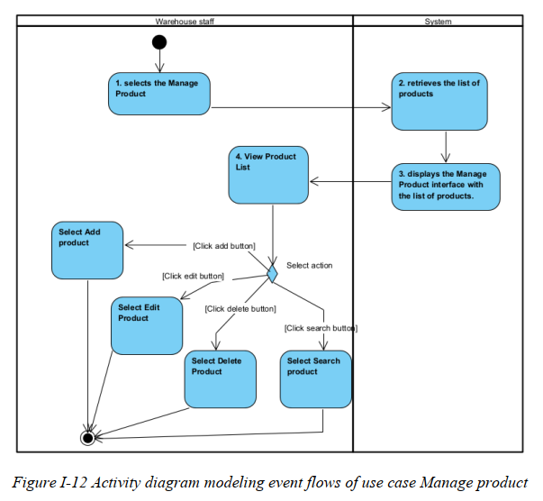
………

II.6 Entity Relationship Diagram
[Provide the entity relationship diagram and the entity descriptions in the table format as below]

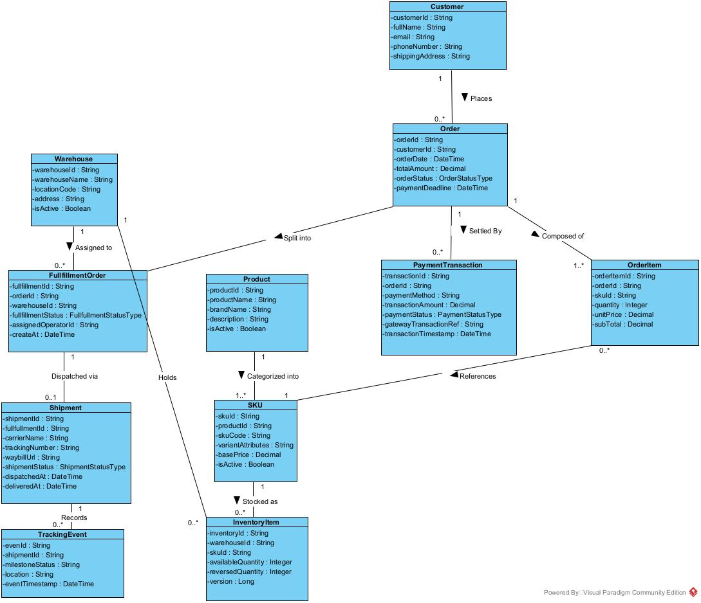

III. Analysis models.

III.1 Interaction diagrams

III.1.1.Sequence Diagram

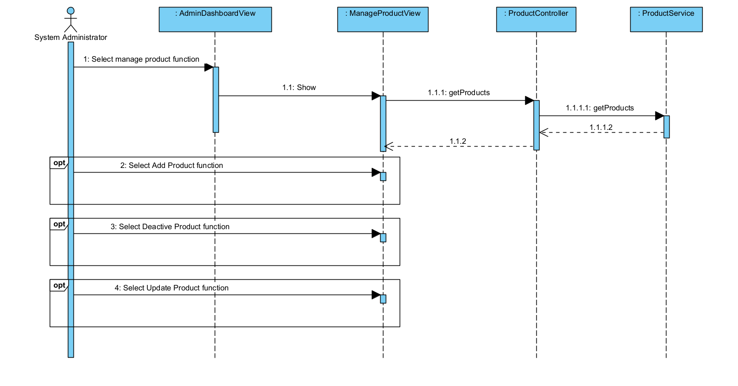
UC-A01: Sequence Diagram for Manage Products Use Case
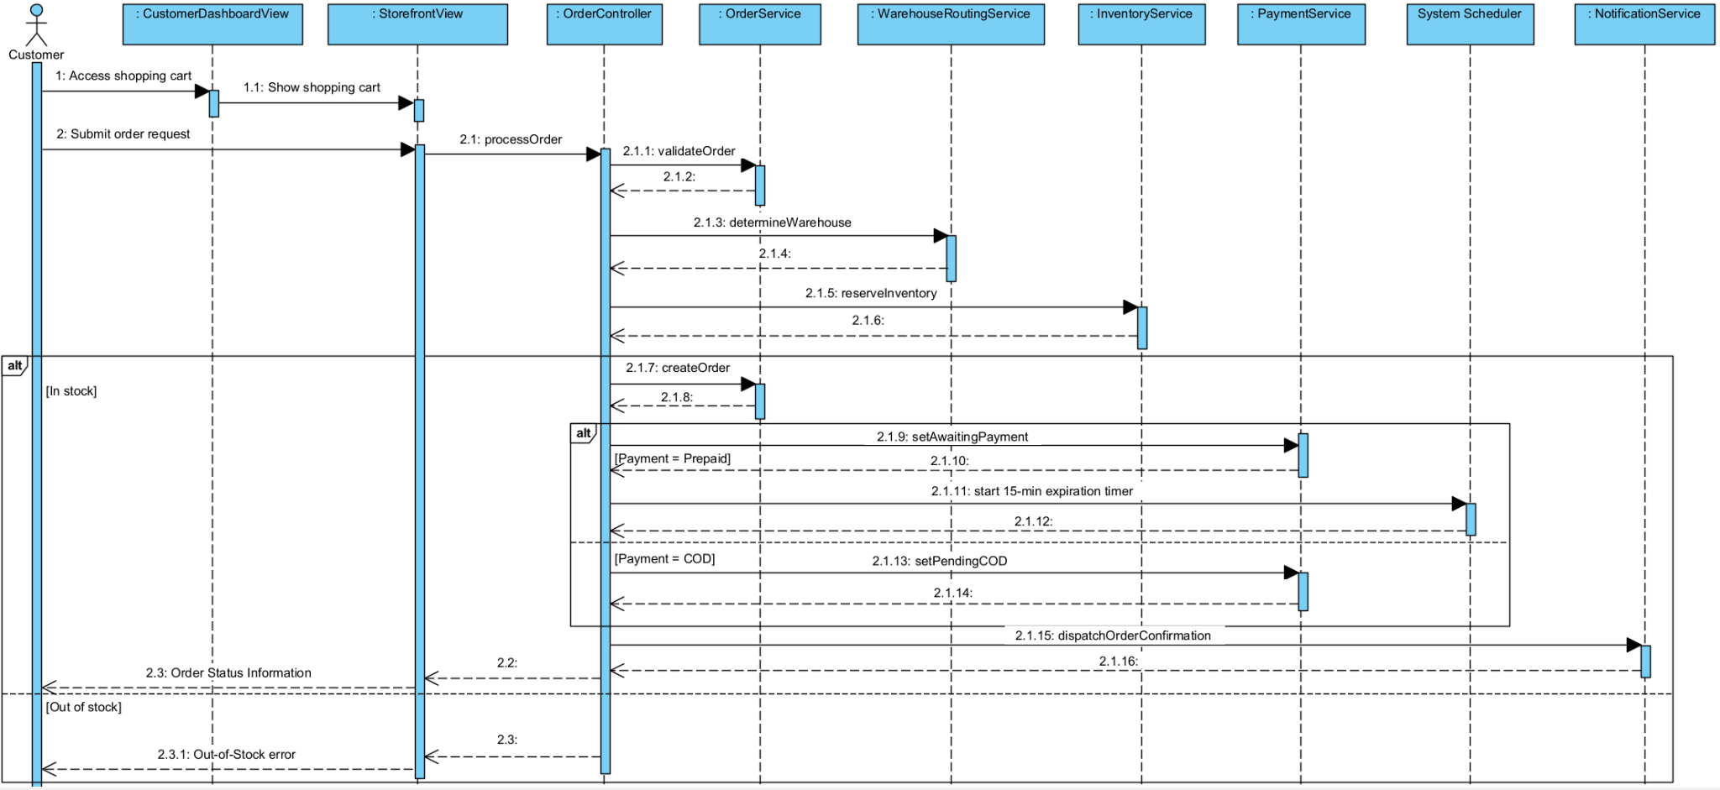
UC-S01: Sequence Diagram for Receive & Process Sales Order Use Case

III.1.2. Communication Diagram

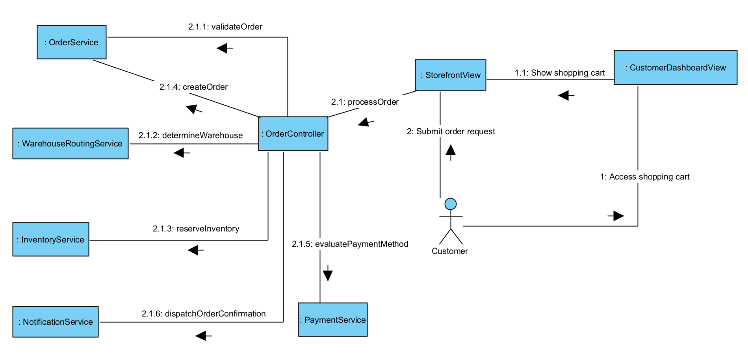
UC-S01: Communication Diagram for Receive & Process Sales Order Use Case

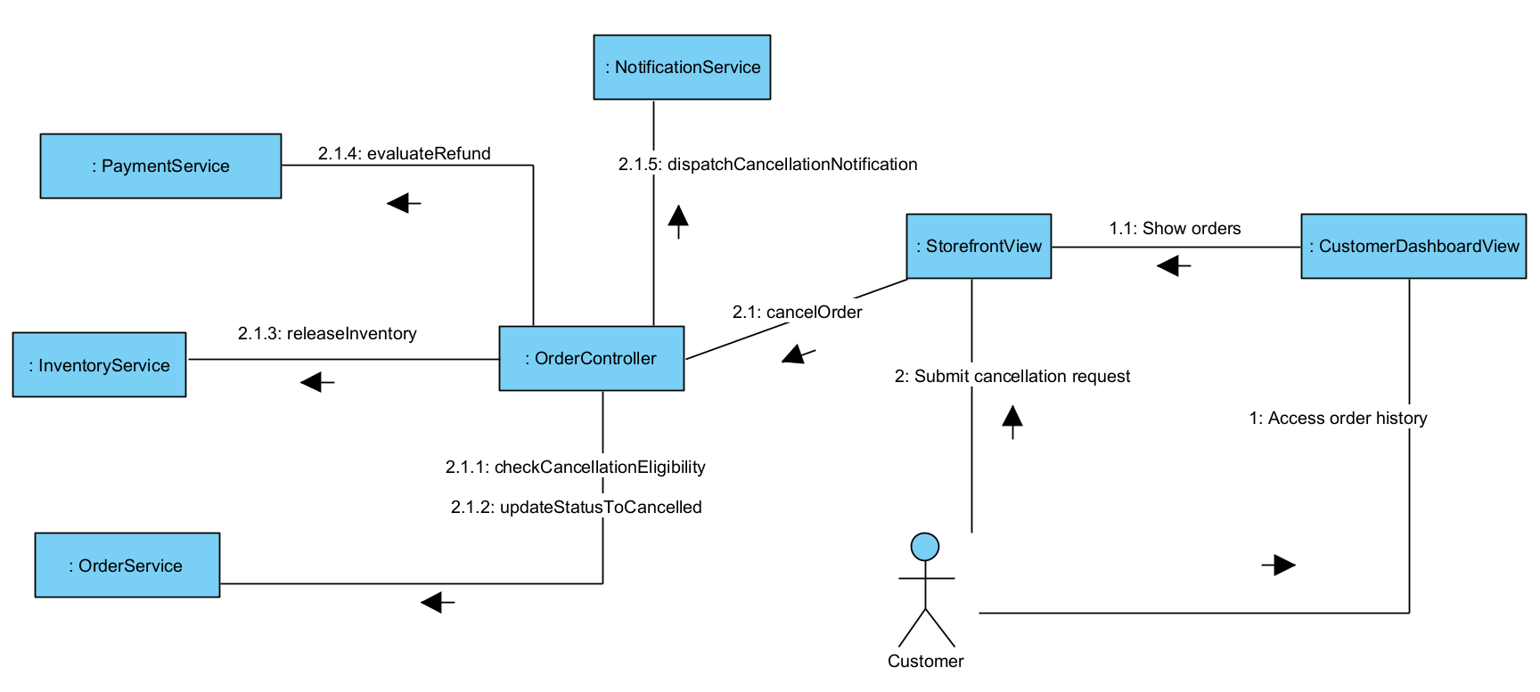
UC-S02: Communication Diagram for Process Order Cancellation Use Case
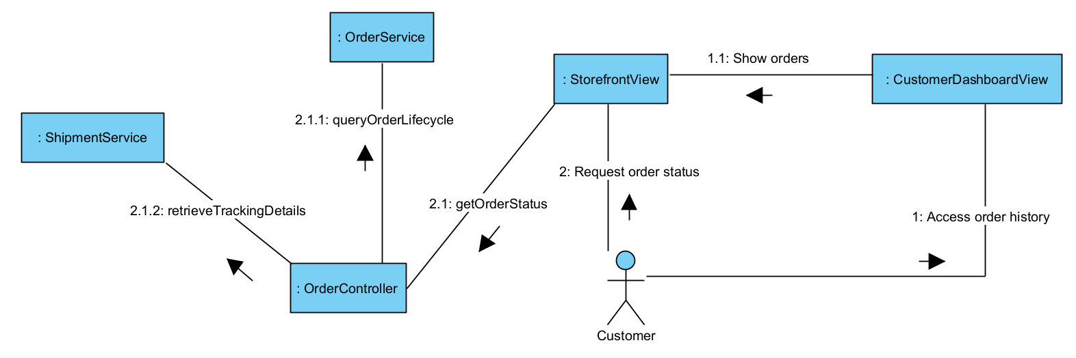
UC-S03: Communication Diagram for Provide Order Status Use Case
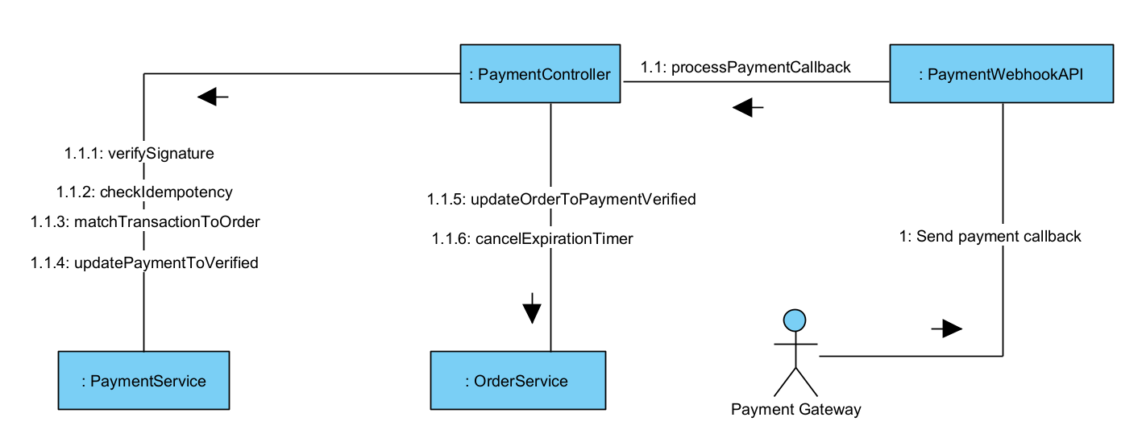
UC-S04: Communication Diagram for Process Payment Transaction Use Case
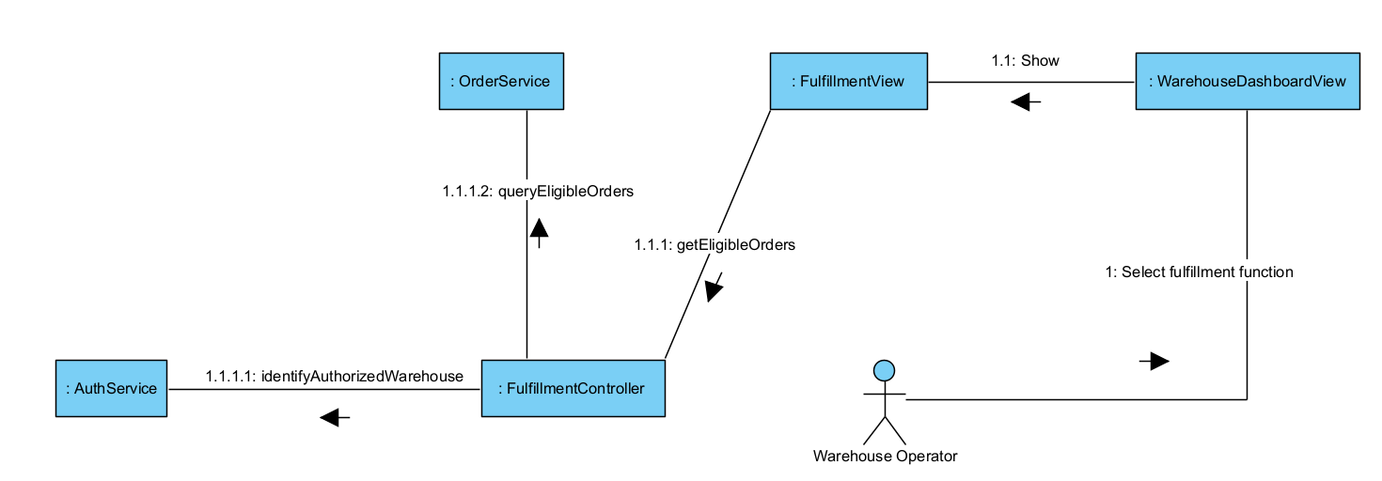
UC-W01: Communication Diagram for View Fulfillment Orders Use Case
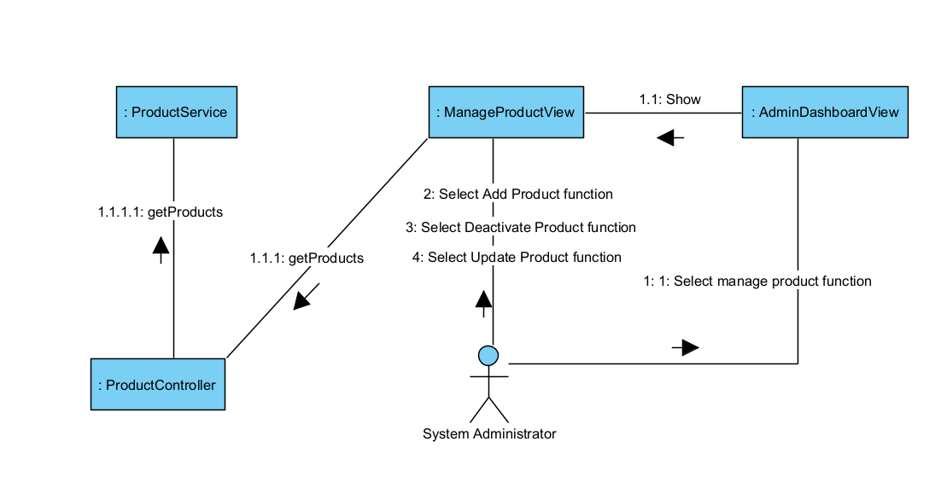
UC-A01: Communication Diagram for Manage Products Use Case
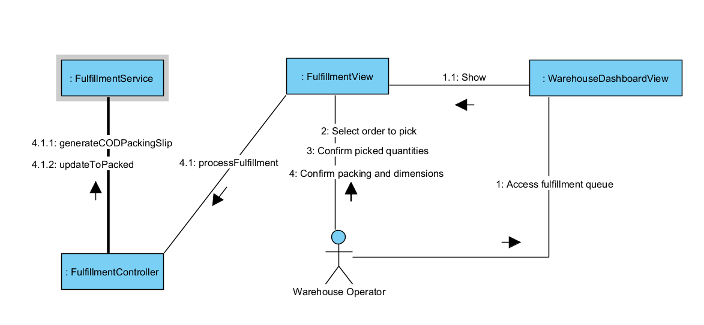
UC-W02: Communication Diagram for Fulfill Order Use Case
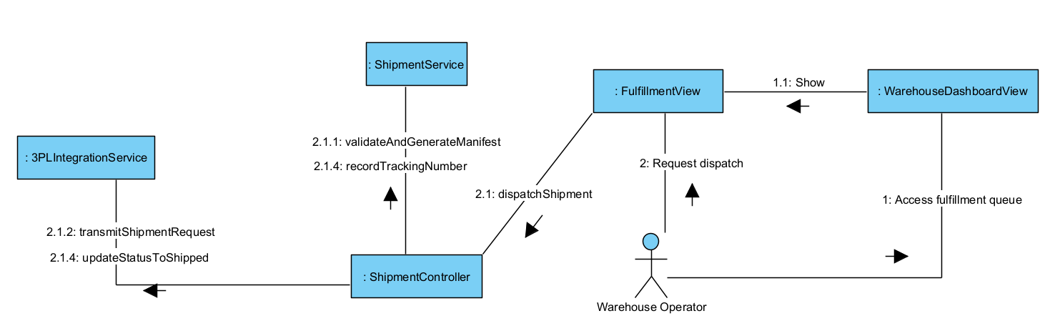
UC-W03: Communication Diagram for Dispatch Shipment Use Case
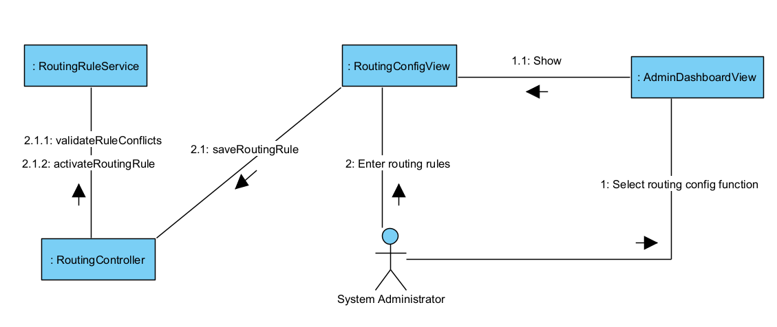
UC-A04: Communication Diagram for Configure Warehouse Routing Use Case
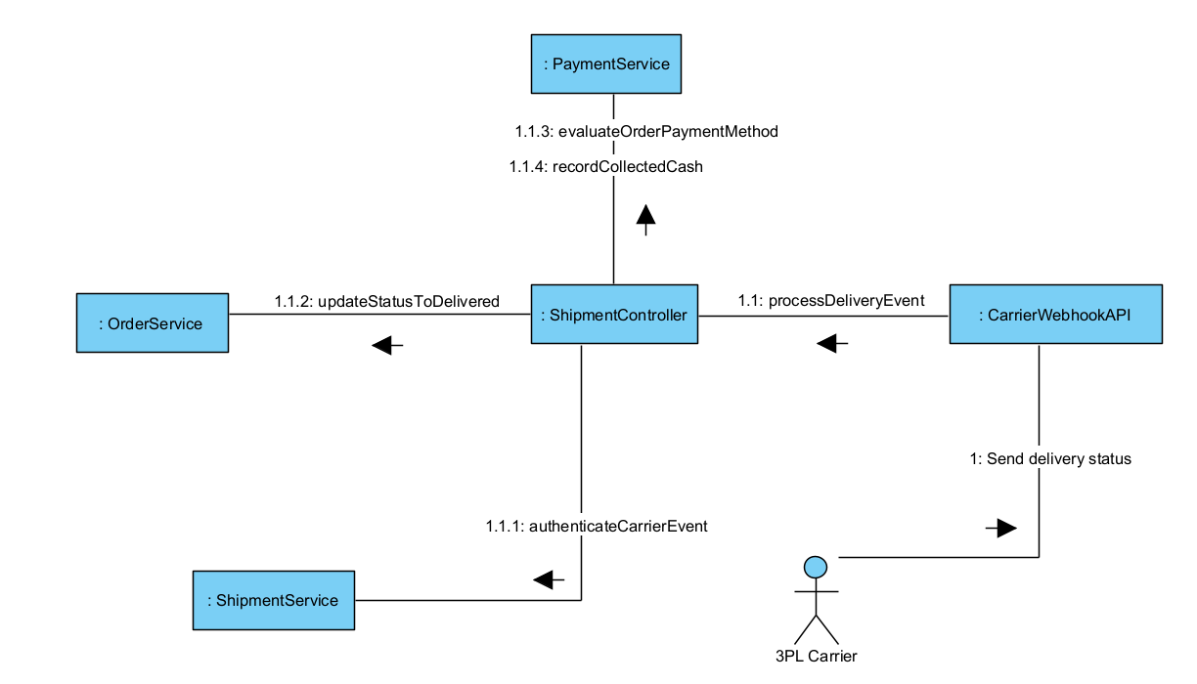
UC-L03: Communication Diagram for Confirm Delivery & COD Collection Use Case

III.2 State diagram
[Provide the State diagram(s) for the feature, see the sample below]

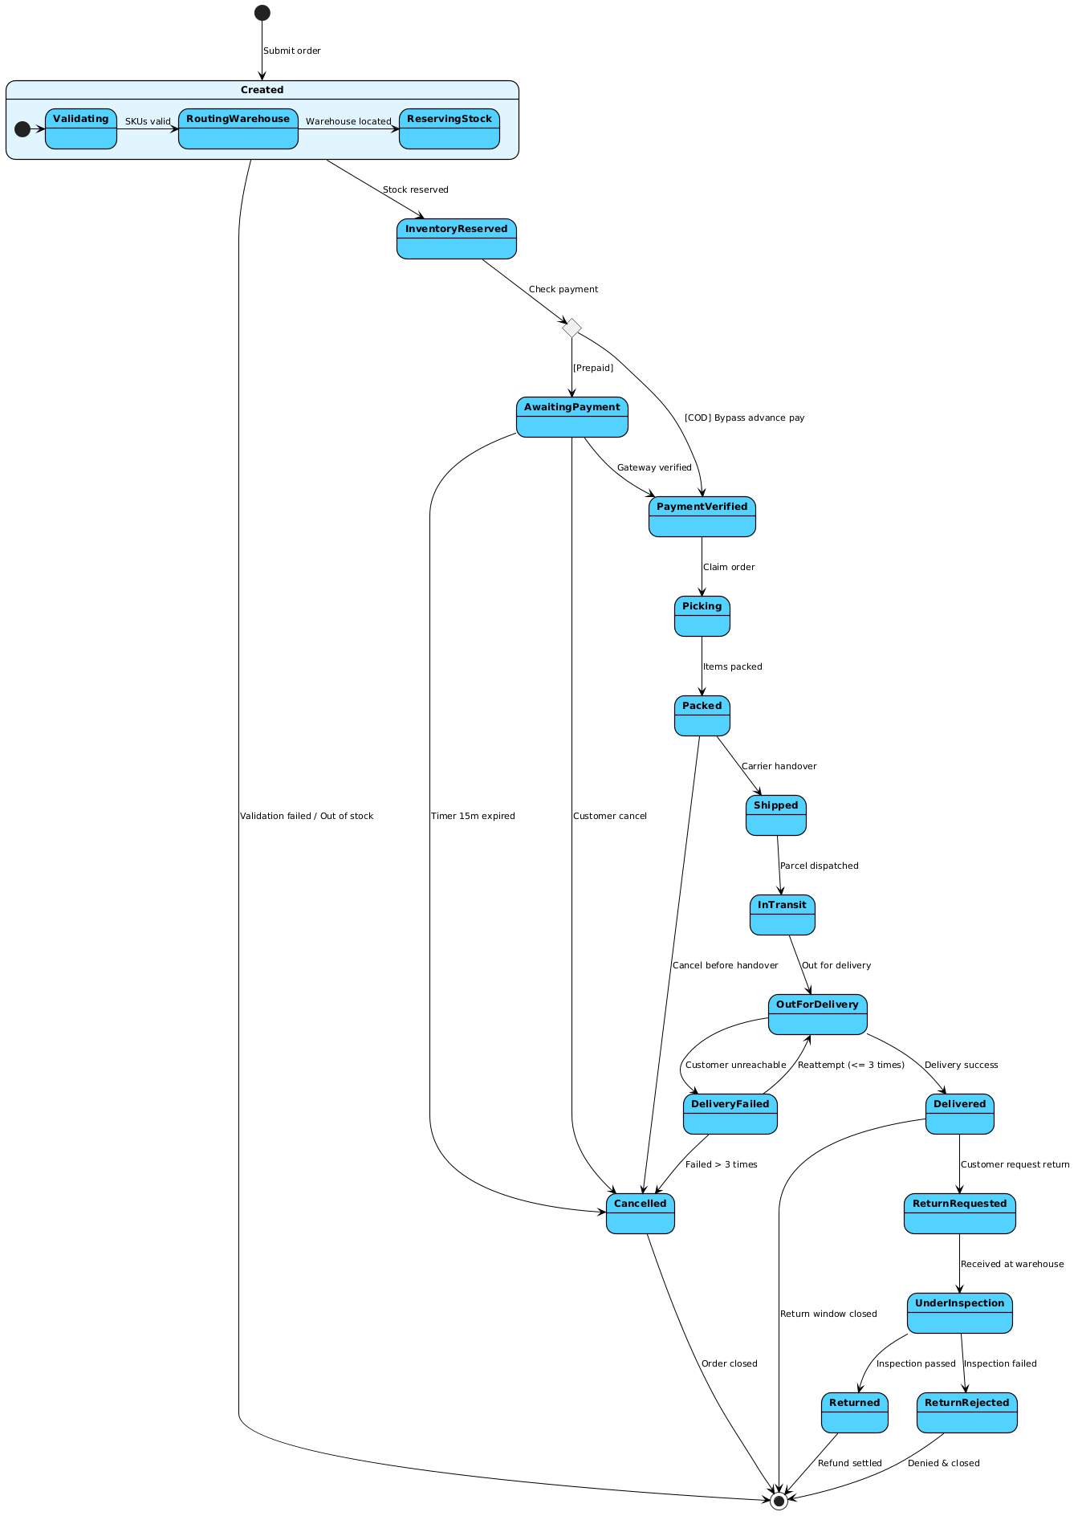

Figure III.2.1: State Diagram for Payment Transaction Processing.

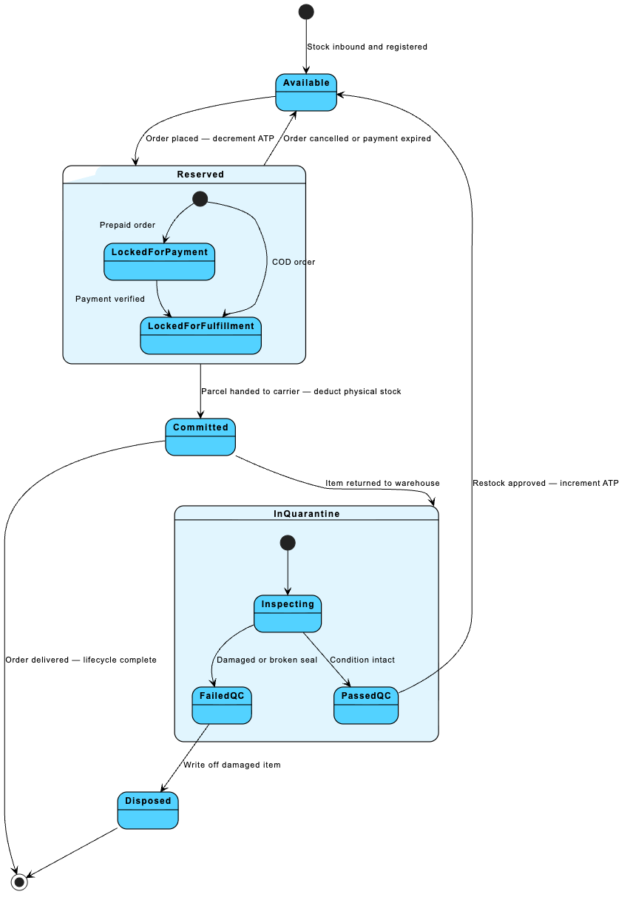

Figure III.2.2: State Diagram for Inventory Allocation & Reservation.

IV. Design specification

IV.1 Integrated Communication Diagrams
Sample
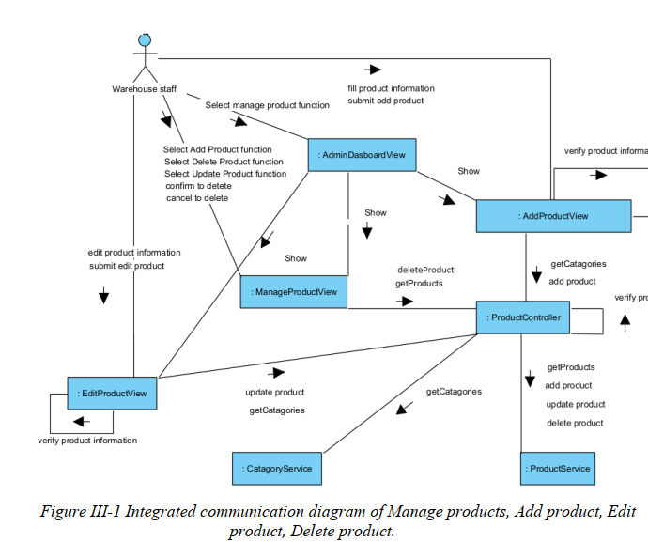

IV.2 System High-Level Design
Sample
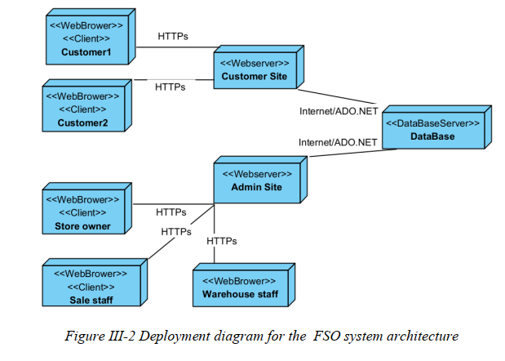

IV.3 Component and Package Diagram

IV.3.1 Component Diagram
Sample
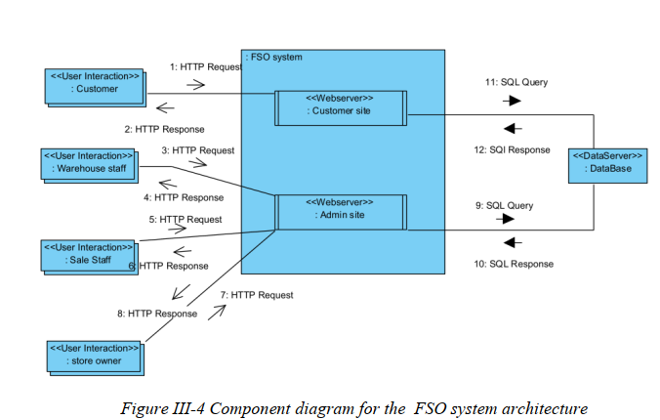

IV.3.1 . Package Diagram
[Provide the package diagram for each sub-system. The content of this section includes the overall package diagram, the explanation, package and class naming conventions in each package. Please see the sample & description table format below (please note: package names don’t follow Java package naming convention yet)]
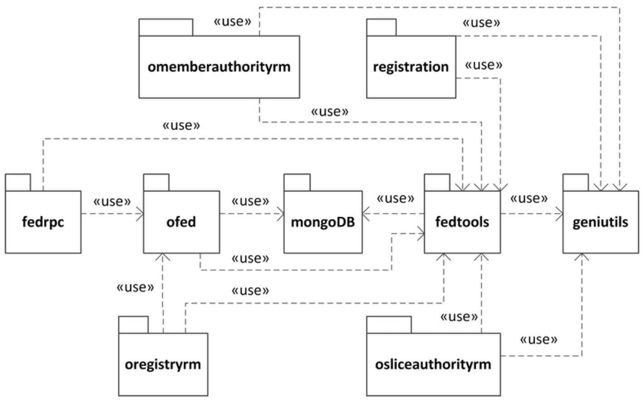
Package descriptions
No | Package | Description
01 | omemberauthorityrm | <Description of the package>
02 | registration | <Description of the package>
03 | fedrpc | <Description of the package>
04 | ofed | <Description of the package>
05 | mongoDB | <Description of the package>
06 | fedtools | <Description of the package>
07 | …

IV.4 Class diagram
[This part presents the class diagram for the relevant feature]
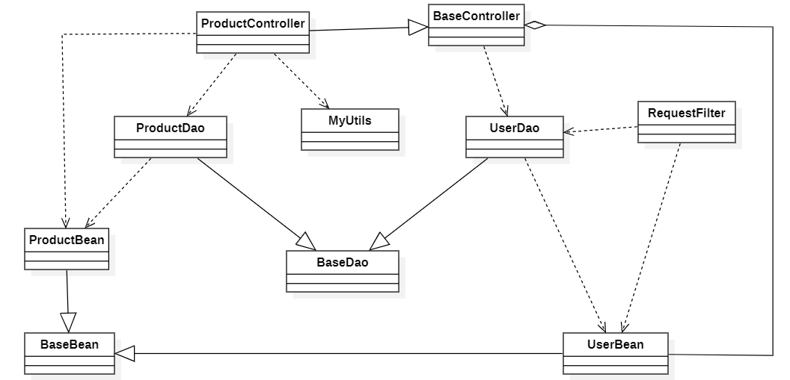

IV.5 Database Design
[Provide the tables relationship like example below – following MySQL database naming convention]

V. Implementation

V.1 Map architecture to the structure of the project
[Provide:
- Overview of the Chosen Architecture
Briefly describe the architectural style (e.g., Layered, MVC, Service-Oriented Architecture)
Explain why it was selected for this project (e.g., to meet non-functional requirements like maintainability, scalability, reusability)
- Mapping to Project Structure
Present the actual project folder/package structure
Map each layer/component in the architecture to concrete project modules]

V.2 Map Class Diagram and Interaction Diagram to Code
[Demo the implementation of several features using design patterns]

VI. Applying Alternative Architecture Patterns

VI.1 Applying the ………….. (ex: Service-Oriented Architecture (SOA)) architecture
[Redesign part of the system architecture using Service-Oriented Architecture (SOA) to improve reusability, scalability, and modularity.
Students must provide:
- Problem Identification
Briefly describe which non-functional requirement(s) are not fully supported by the current architecture (e.g., NF-05: Reusability)
- SOA-Based Solution
Reorganize system components into independent services
E.g., refactor FSOData into separate service modules
- Supporting Diagrams
Deployment Diagram
Updated Class Diagram
Component Diagram showing separate services]

VI.2 Applying Service Discovery Pattern in the service-oriented architecture
[Support dynamic service registration and discovery in SOA or microservice-based architecture for horizontal scalability and ease of expansion.
Students must provide:
- Problem & Requirement
Explain the relevant non-functional requirement (e.g., NF-06: Scalability)
Describe the need for service discovery in a growing system (e.g., multiple branches, independent modules)
- Service Discovery-Based Solution
Integrate a Service Discovery Pattern
Mention possible technologies: Consul, Eureka, Kubernetes DNS
- Supporting Diagrams
Deployment Diagram (with multiple instances and registry)
Updated Class/Component Diagram including a Discovery Service]

